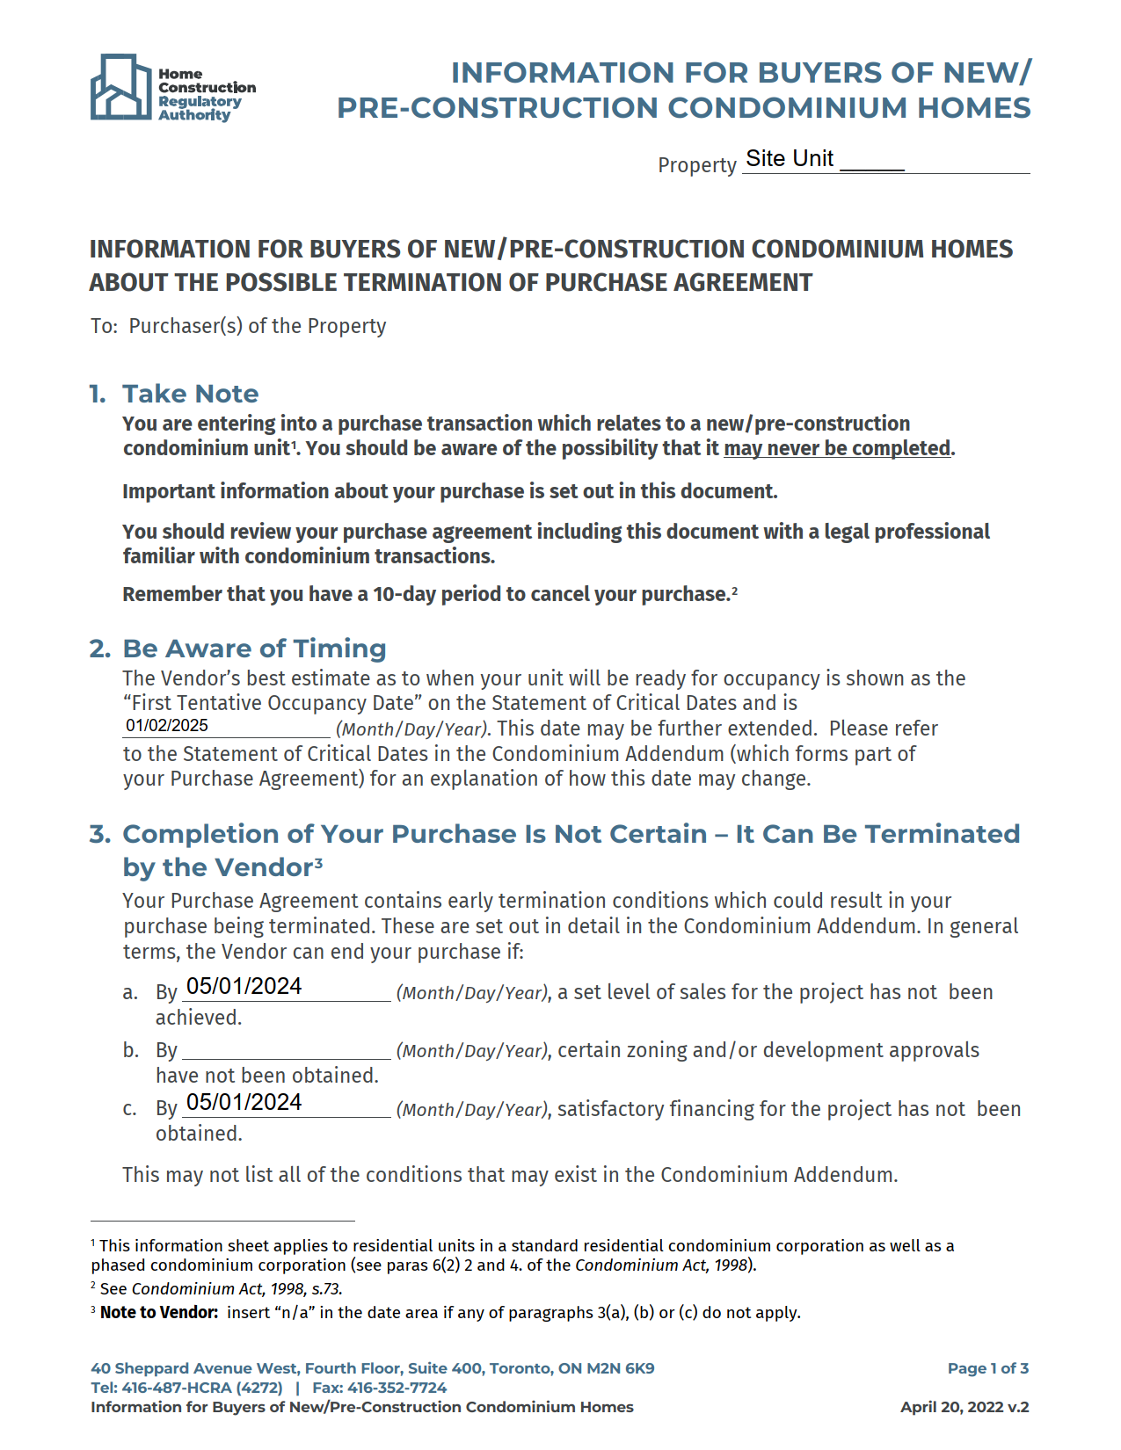
[LOTNUMBER]
[LOTNUMBER]
N/AN/A
[SETTLEMENTDATE]
06/01/2025

06/01/2025
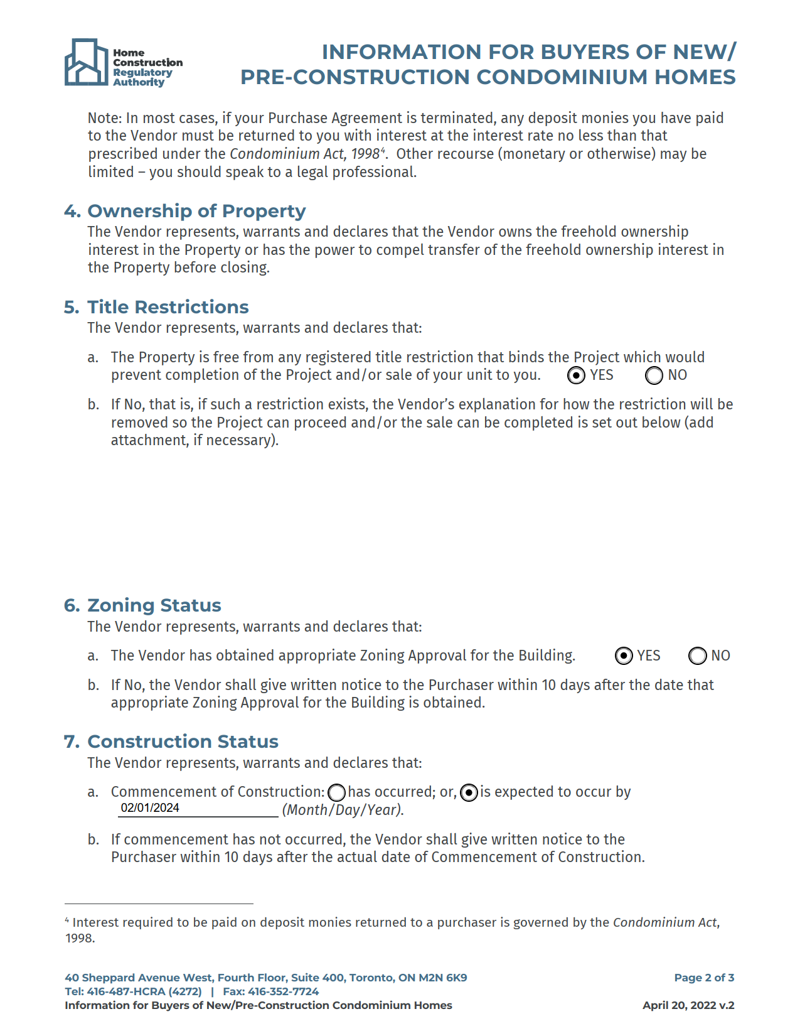

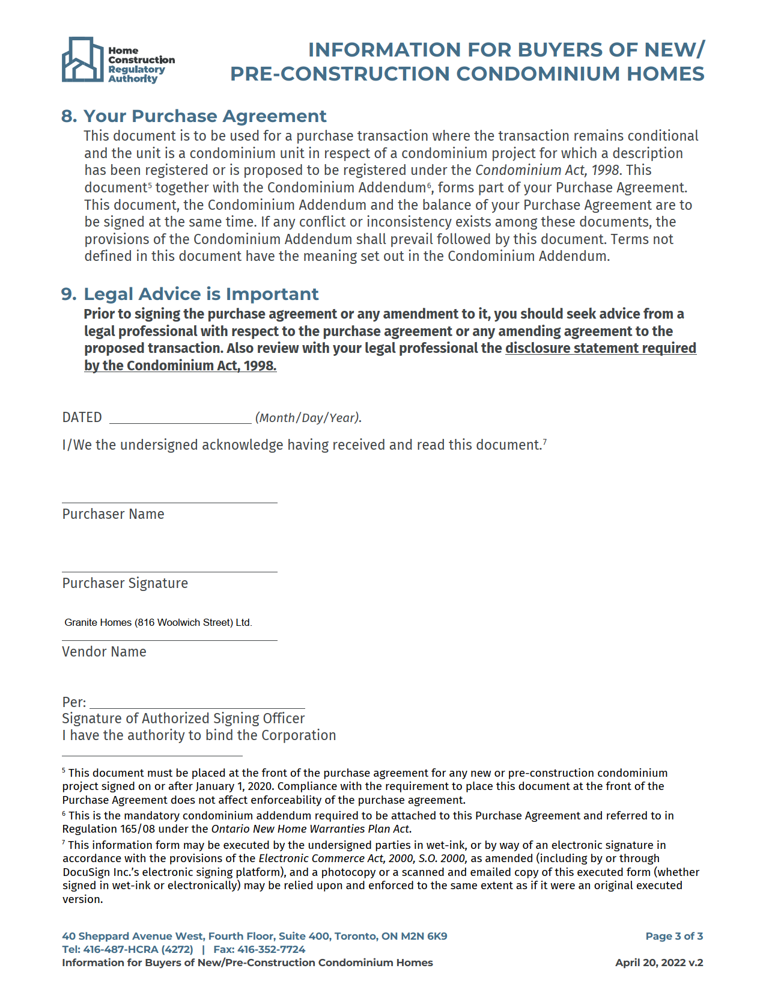
[FIRSTNAME0000] [LASTNAME0000], [FIRSTNAME0001] [LASTNAME0001], [FIRSTNAME0002] [LASTNAME0002]

AGREEMENT OF
PURCHASE AND SALE

Wellington Standard Condominium Plan No. 299
NORTHSIDE

824 Woolwich Street, Guelph

GRANITE HOMES (816 WOOLWICH STREET) LTD.
7 Edinburgh Road South, Guelph, Ontario N1H 5N8
Tel. (519) 822-3988

[LOTNUMBER]
Marketing Unit:
Civic Address: [LOTNUMBER] 824 Woolwich Street, Ontario

PROPERTY
- [FIRSTNAME0000] [LASTNAME0000], [FIRSTNAME0001] [LASTNAME0001] and [FIRSTNAME0002] [LASTNAME0002] (the “Purchaser”) agrees to purchase from GRANITE HOMES (816 WOOLWICH STREET) LTD. (the “Vendor”):

if the Unit is in the registered condominium plan | Residential Site Unit Number [LOTNUMBER], being legal Unit _______, Level 1, Wellington Standard Condominium Plan No. 299, municipally known as [LOTNUMBER]- 824 Woolwich Street, Ontario (the “Unit”)
If the Unit is in a Phase that is not yet registered | Proposed Residential Unit Number [LOTNUMBER], Building _________, municipally known as [LOTNUMBER]- 824 Woolwich Street, Ontario (the “Unit”) which is to be registered within a future phase to be added to Wellington Standard Condominium Plan No. 299 by amendment to the declaration and description of that Condominium Plan

in accordance with the plans set out in the Schedules attached hereto examined by the Purchaser and subject further to the provisions set out in any Schedule or Condition attached hereto.

- The Purchaser acknowledges the Unit is a registered or proposed unit within a standard condominium plan that is to be phased pursuant to the Act as explained in more detail in the disclosure statement.
PURCHASE PRICE
- The Purchaser agrees to purchase the Unit for the sum of $[BASEPRICE ++ TOTALEXTRAS_WTAX] Dollars (or) ($[$BASEPRICE ++ TOTALEXTRAS_WTAX]) of lawful money of Canada (the “Purchase Price”), payable as follows:

  - deposits are payable in the amounts and dates as set out in Schedule “A(2)” (Deposit Schedule) as deposits to be credited toward the Purchase Price on Closing; whereby the Vendor’s solicitor must be in receipt of all deposits outlined in Schedule “A(2)” by the dates set out therein. For any deposits that are to be paid after the initial deposit, post-dated cheques for all of the same shall be provided to the Vendor at the time of the delivery of the initial deposit; and,

  - On the Closing Date (as defined below), the Purchaser shall pay the balance of the Purchase Price subject to usual adjustments and those set out herein. Notwithstanding anything herein to the contrary, at the option of the Vendor's solicitor, closing funds are to be provided by wire transfer that qualifies as a payment pursuant to the electronic funds transfer system (Lynx) that is owned and operated by the Canadian Payments Association as detailed in By-Law No. 9 of the said Association. Any administrative or bank fee levied by the Vendor’s solicitor’s financial institution in association with closing funds being provided to the Vendor’s solicitor shall be the responsibility of the Purchaser and are to be paid on Closing. No Certified Cheques, Bank Drafts or Money Orders will be accepted. The Purchaser’s solicitor will, prior to Closing, provide a copy of the wire confirmation, and a signed Confirmation as to Closing Funds from the Purchaser’s solicitor in the form to be provided by the Vendor’s solicitor prior to Closing.

- The Purchase Price must be paid in full on Closing. No holdback of the Purchase Price is permitted for any reason.

PARKING UNIT
[If incomplete, no Parking Unit is being purchased by the Purchaser and none shall be conveyed on closing.]

- The Purchaser agrees to purchase one (1) Parking Unit. The purchase price of the Parking Unit shall be ________________ Dollars ($_______.___). The purchase price for the Parking Unit is payable on Closing in addition to the purchase price for the Residential Unit set out in paragraph 3 above. The location of the Parking Unit being conveyed will be determined by the Vendor prior to Closing in the Vendor’s sole discretion.

- Any later reference in this Agreement to the Unit shall include the Residential Unit set out in paragraph 1 above and the Parking Unit being purchased by the Purchaser (if any) and references to the Purchase Price shall refer to the purchase price(s) of both the Residential Unit and the Parking Unit.
SCHEDULES
- The following Schedules form an integral part of this Agreement, whether same are executed by the parties or not. All Schedules are deemed to be dated on the same date as this Agreement.
SCHEDULES - A(1)-Pricing, A(2)-Deposit Schedule, B(1)- Specifications, C(1)-Floor Plan, C(2)-Site Plan, C(3) Elevations, D(1) Construction Safety Policy, D(2) Colour Selections, G(1) General Provisions, H(1) HST, J(1) Document Registration Schedule, O(1) Terms of Interim Occupancy; P(1) Power of Attorney; S(1) Assignment Schedule; T(1)Tarion Addendum, and other schedule(s) (specific as required).

CONDITIONS: E(1)-Cooling-Off Period

DEFINITIONS

- In this Agreement the following definitions are applicable:

  - “Act” means the Condominium Act, 1998 of Ontario and its regulations;
  - “Building Authority” means any public and/or private governmental authority, quasi-governmental authority, agency, body, department, or entity whatsoever having jurisdiction over, without limiting the generality of the foregoing, the regulation, underwriting, claims assessment, compliance, or investigations of new home building and construction in the Province of Ontario;
  - “Business Day” means any day other than: Saturday, Sunday, or a statutory, civic or bank holiday in the Province of Ontario;
  - “Condominium Plan” means Wellington Standard Condominium Plan No. 299 as amended from time-to-time;
  - “Corporation” means the Wellington Standard Condominium Corporation No. 299;
  - “Creating Documents” means the registered declaration and description and prposed phasing amendments and descriptions required to be registered under the Act in order to create the Corporation and includes any bylaw(s) registered prior to the registration of the transfer/deed of the unit in favour of the Purchaser;
  - “Extras” means selections, additions, deletions, options, extras, and changes which are not included within the list of standard features and not otherwise included in consideration of the payment of the base Purchase Price;
  - “Municipality” means any municipal corporation (whether local, county, or regional) having jurisdiction over the Property and its agencies;
  - “Project” means the parcel shown on the attached site plan on which the condominium project is to be built; and,
  - “Property” has the meaning given to such term by the Act and includes the “Unit”.
DEPOSITS AND EXTRAS PAYABLE TO VENDOR’S SOLICITORS
- In the event that the Purchaser is a non-resident of Canada within the meaning of the Income Tax Act, Canada, the Purchaser acknowledges and agrees that the Vendor shall be entitled to withhold and remit to Canada Revenue Agency the appropriate amount of withholding tax with respect to interest accrued on deposits.
- All deposits and payments on account of Extras shall be payable in trust to Robson Carpenter LLP, who are the solicitors for the Vendor in the timelines set out in Schedule “A(2)”. The Purchaser is hereby directed to pay the Vendor’s solicitors Robson Carpenter LLP, or as they further direct, the whole of the proceeds due on Closing including payments on account of Extras with respect to this transaction in trust. This direction can only be cancelled by an instrument in writing executed on behalf of the Vendor and delivered to the Purchaser or the Purchaser’s solicitor. The deposits (provided they are not in excess of Twenty Thousand Dollars ($20,000.00)) are guaranteed by the Ontario New Home Warranties Plan Act and will only be released from trust in accordance with the regulations to the Act.
- In the event that this Agreement is terminated on account of default by the Vendor, any deposits shall be returned to the Purchaser (with interest, if any, calculated at the rate prescribed by the Act) and without deduction. However, where a mutual release is executed by the Purchaser and the Vendor, no interest is payable to the Purchaser on account of the deposits. The Purchaser acknowledges that the Vendor shall not be liable for any damages or costs whatsoever incurred by the Purchaser resulting from the termination of this Agreement including, without limiting the generality of the foregoing, relocation costs, professional fees and disbursements, opportunity costs, loss of bargain or any other damages or costs incurred by the Purchaser, directly or indirectly. The Purchaser acknowledges and agrees that this provision may be pleaded by the Vendor as a complete defence to any claim which may be made by the Purchaser against the Vendor.
MONTHLY OCCUPANCY FEE
- The Monthly Occupancy Fee shall be the aggregate of the following:
  - the total of interest calculated on a monthly basis on the unpaid balance of the Purchase Price as it now exists at the prescribed rate;
  - the projected monthly common expenses contribution for the Unit; and
  - at the option of the Vendor, such amount as the Vendor determines on account of monthly Property Taxes attributable to the Unit.
- For greater certainty, notwithstanding any payment on account of Property Taxes contained within the Monthly Occupancy Fee:
  - the Purchaser remains responsible for all Property Taxes as set forth in paragraph 19 below; and
  - the inclusion of any such amount on account of Property Taxes in the Monthly Occupancy Fee shall not be construed to limit any Property Taxes owing by the Purchaser hereunder.
- See the Terms of the Interim Occupancy Schedule to this Agreement for additional provisions relating to interim occupancy of the Unit.
DATE OF COMPLETION
- The completion of this transaction (“Closing”) is to take place:

if the Unit is in the registered condominium plan | on or before 5:00 p.m. on the __________ day of ________________, 20____. The Addendum attached as Schedule T(1) hereto is required to be attached to this Agreement by the regulations to the Ontario New Home Warranties Plan Act and the said Addendum is completed and attached. As the said Addendum only speaks to occupancy (which is not applicable to this Agreement as no occupancy before Closing is contemplated by this Agreement) the parties covenant and agree that none of the terms of the said Addendum with respect to occupancy of the Unit are applicable to this transaction and the said Addendum provisions relating to the occupancy of the Unit are of no force or effect.
If the Unit is in a Phase that is not yet registered | on or before 5:00 p.m. on a date designated in writing by the Vendor’s solicitors after the registration of the amendment and description adding the Unit to the Condominium Plan which date so designated shall be within ten (10) to seventeen (17) days after such registration. There may need to be differing Closing dates for some units as it may not be reasonable to attempt to close all unit sales on the same day.

This date is referred to herein as the “Closing Date”. On the Closing Date the Vendor will transfer to the Purchaser the title to the Unit. Closing is to take place prior to 5:00 p.m. on the Closing Date.
TAKING POSSESSION
- The Purchaser will go into possession of the Unit on the Firm Occupancy Date, and shall start to pay the Monthly Occupancy Fee as of the Firm Occupancy Date and all utility charges with respect to the Unit in accordance with the Terms of Interim Occupancy Schedule. If the amendment to the Condominium Plan is registered by the Firm Occupancy Date and the Closing Date as set by paragraph 15 would be a date that is earlier than the Firm Occupancy Date, completion (the exchange of the balance of the Purchase Price in exchange for a transfer/deed) will take place on the Firm Occupancy Date and upon completion on such date there will be no Monthly Occupancy Fee charged to the Purchaser.
ADJUSTMENTS
- Local improvements, assessment rates, occupancy charges, common expenses and other charges (excluding Property Taxes which are specifically addressed below) shall be apportioned to the Closing Date (the day itself to be apportioned to the Purchaser).

- For the purposes of this Agreement:

  - “Annual Estimated Taxes” means the amount of the Property Taxes that are estimated by the Vendor, acting reasonably, as likely to be separately assessed after the Tax Adjustment Date on an annual basis against and on account of the Property from the Tax Adjustment Date;

  - “Property Taxes” means all real property/municipal taxes relating to the Property including, but without limitation or duplication, (i) all real property/municipal taxes relating to the Property on the basis of the Property being separately assessed regardless of whether the Property has in fact been separately assessed at the relevant time; (ii) the Property’s pro rata share of any such real property/municipal taxes relating to the development as a whole (land taxes or pre assessed taxes); and (iii) any other real property/municipal taxes that may be attributed to the Property as determined by the Vendor in the Vendor’s absolute discretion acting reasonably; and

  - “Tax Adjustment Date” means the earlier of Closing Date and the Firm Occupancy Date.

- The Purchaser acknowledges and agrees that the Purchaser shall be responsible for all Property Taxes from and after the Tax Adjustment Date. The Vendor and Purchaser acknowledge and agree that the Vendor or a current or prior owner of the Property (such current and/or prior owner being referred to herein as an “Owner”) may receive bills for Property Taxes for a period of time after Closing notwithstanding that the Property has been conveyed to the Purchaser and that the Purchaser is solely responsible for the payment of Property Taxes from and after the Tax Adjustment Date regardless. Currently, the Municipal Property Assessment Corporation has a period of up to three (3) years from the Closing to complete its assessment of the Property and provide assessment information to the Municipality. Until such time as the Municipality amends its information with respect to the Property, the Vendor or an Owner is expected to continue to receive bills for Property Taxes. The Purchaser acknowledges and agrees that, notwithstanding that such bills for Property Taxes are addressed to the Vendor or an Owner, the Purchaser is solely responsible to pay all Property Taxes from and after the Tax Adjustment Date.

- To give effect to paragraph 19 above, the following payments (collectively, the “Property Tax Payments”) with respect to Property Taxes will be made by the Purchaser on Closing:

  - an amount equal to the Annual Estimated Taxes for the year in which Tax Adjustment Date occurs divided by three hundred sixty five (365) and multiplied by the number of days from and including the Tax Adjustment Date to and including December 31 of such calendar year; and

  - an amount equal to the aggregate Annual Estimated Taxes for up to one (1) calendar year following the calendar year in which the Tax Adjustment Date occurs as determined by the Vendor in the Vendor’s sole discretion.
The Property Tax Payments required by subparagraphs (a) and (b) of this paragraph shall be reduced by any amounts paid by the Purchaser on account of Property Taxes that have been included in the Monthly Occupancy Fee during the relevant period, if any.

- The Property Tax Payments so collected will be applied by the Vendor on account of Property Taxes that accrue after the Tax Adjustment Date until such time as Property Taxes are billed to the Purchaser. Even after Property Taxes are billed to the Purchaser the Vendor has the right to make payment from the Property Tax Payments so collected of all Property Taxes billed to the Vendor or any Owner for the period prior to such time as the Purchaser becomes solely responsible to pay the Property Taxes. The Purchaser expressly authorizes the Vendor to make some or all of the following payments from the Property Tax Payments: (i) payments to the Vendor or any Owner to reimburse the Purchaser or the Owner on account of Property Taxes paid by the Vendor or the Owner relating in whole or in part to any period of time after the Tax Adjustment Date; and (ii) pay any Property Taxes that are billed to the Vendor or an Owner to the municipality or to the Owner, as applicable. At such time as the Vendor is satisfied in the Vendor’s sole discretion that the Vendor or an Owner is no longer being billed for Property Taxes and such bills for Property Taxes are being billed directly to the Purchaser, and that all Property Taxes for the period prior to such time as the Purchaser becomes solely responsible to pay the Property Taxes have been paid, any remaining amounts of the Property Tax Payments over what is paid in accordance with this section will be returned to the Purchaser. Any deficiency with respect to the same is to be made up for and paid by the Purchaser as soon as such deficiency is known and requested of the Purchaser by the Vendor. For greater certainty, if the actual Property Taxes for the relevant periods exceed the Property Tax Payments, the Vendor will have no obligation to make any payments to the municipality or any Owner in respect thereof and the responsibility for the payment of such Property Taxes shall be solely the obligation of the Purchaser. If, notwithstanding that it has no obligation to do so, the Vendor makes any payments on account of Property Taxes in excess of the Property Tax Payments to the municipality or an Owner, the Purchaser shall reimburse the Vendor in respect thereof forthwith upon the Vendor providing the Purchaser notice of such payment or payments being made.

- The Purchaser will, in reliance on the Vendor’s undertaking to readjust, complete the closing of this Agreement without holdback despite the possibility of or fact there are unpaid Property Taxes and the Vendor shall honour the Vendor’s undertaking to readjust with respect to such Property Taxes as set forth above.

- The Vendor and the Purchaser hereby mutually undertake to make any necessary adjustments or readjustments for Property Taxes, local improvements and other charges upon receipt of the assessment for the Unit and with respect to any other adjustments/credits/items shown on the statement of adjustments.

- The amount of any new and/or increase in development charges authorized by the Development Charges Act and any new and/or increase in education development charges authorized by the Education Act paid by the Vendor on account of the Unit over and above the rate(s) on account thereof that existed as of the date this Agreement is entered into shall be payable by the Purchaser and adjusted on Closing in favour of the Vendor on the statement of adjustments. This adjustment includes any payments required to be made by the Vendor pursuant to any Community Benefits Charge by-law under Section 37 of the Planning Act, relating to the Property. Any such adjustments pursuant to this paragraph shall not exceed Five Thousand Dollars ($5,000) plus H.S.T.

- The Purchaser agrees to pay to the Vendor the cost of enrolling the Unit with Tarion Warranty Corporation or any successors, and any licensing, enrollment, or regulatory fees paid or payable to the Home Construction Regulatory Authority on account of the Unit. Any reference in this Agreement to the cost of so enrolling the Unit shall include all costs and charges directly or indirectly relating thereto, including without limiting the generality of the foregoing the Unit enrolment fee, and all Provincial and Federal taxes applicable thereto.

- An administrative fee of Two Hundred and Fifty Dollars ($250.00) plus H.S.T. shall be charged to and be payable by the Purchaser for any cheque delivered by the Purchaser to the Vendor and not accepted by the Vendor’s bank for any reason. The N.S.F. administration charge is due and payable immediately upon request by the Vendor or, at the option and in the absolute discretion of the Vendor, as an adjustment on Closing. Payment of the N.S.F. administration charge does not relieve the Purchaser from liability for default and acceptance of same by the Vendor is not a waiver of default.

- The balance due on Closing shall also be adjusted in favour of the Vendor as to all prepaid and accrued expenses or charges.
- In addition, and without limiting the generality of the foregoing, the following adjustments shall be made on Closing:
  - in favour of the Vendor for assessments prepaid or owing for contribution towards the common expenses and/or reserve fund;
  - in favour of the Vendor for an amount equal to the Unit’s percentage share of the common expenses multiplied by the amount of the first insurance premium paid or payable on account of the Corporation’s insurance costs in light of the fact there may be insufficient funds in place at the time of the registration of an amendment to the Condominium Plan to pay this premium. If the Vendor has paid any of the Vendor’s funds towards the costs of such insurance premium the Vendor may to the extent the Vendor has made payment of the same on account of the Corporation retain the amount paid pursuant to this subparagraph. Otherwise the amount so paid will be delivered to the Corporation by the Vendor;
  - in favour of the Vendor any other prepaid or current expense, such as gas, electricity, water, etc., which shall be adjusted by attributing to the Unit its share of such expenses, as determined by such Unit’s proportionate share of the common expenses although it is expected that water, gas and electricity will each be separately metered to the Unit and the Purchaser will have signed up to pay the same from the earlier of occupancy and the Closing Date;
  - in favour of the Purchaser any interest owing to the Purchaser on account of the provisions of the Act with respect to the deposits paid by the Purchaser; and
  - in favour of the Vendor of a deposit administration fee of Three Hundred Dollars ($300.00) plus H.S.T. unless the Purchaser elects to pay all of the deposits at the time the initial deposit is due in which case this deposit administration fee will not be collected.
- If any of the adjustments to be made on Closing cannot be accurately determined at the time of Closing the Vendor may estimate the adjustment to be made and Closing shall take place in accordance with this estimate. There shall be a later and final adjustment when all the items to be adjusted can be accurately determined if necessary.
- If the Purchaser requests an extension of the Closing Date and if the Vendor agrees in writing to extend the Closing Date (which the Vendor is not obligated to agree to) then there shall be a charge to the Purchaser which shall be adjusted in favour of the Vendor on Closing. For each extension request made by the Purchaser and granted by the Vendor, the amount to be adjusted on Closing shall be a minimum of One Hundred Dollars ($100.00) plus H.S.T. for each day, including days that are not a Business Day, that the Closing Date is so extended in addition to all other readjustments and charges on account thereof. The Purchaser shall also be responsible for any additional mortgage discharge fees and/or discharge registration costs that arise on account of the extension of the Closing Date. Such additional mortgage discharge fees shall be adjusted in favour of the Vendor on Closing.

- The Purchaser is hereby informed there may be security or other deposits required to be paid by the Corporation once the Condominium Plan or an amendment thereto is registered to utility companies and/or suppliers on account of installation of meters and/or supply of services to the common elements and/or Units. If any such security or other deposits are required, the Purchaser agrees to pay to the Vendor as an adjustment on Closing (or after Closing if the Vendor makes such request for payment after Closing) a percentage of the amount of each such deposit based upon the proportionate contribution to the common expenses payable on account of each Unit being purchased by the Purchaser as set out in Schedule “D” to the registered declaration of the Corporation (“Deposits Adjustment”).

- The Vendor covenants to deliver the amounts paid by the Purchaser in accordance with the foregoing paragraph to the Corporation to be available to be paid on account of required security or other deposits except with respect to any Unit being purchased herein for which the percentage share of such security or other deposits has already been paid. With respect to any such Unit for which the percentage share of such security or other deposits has already been paid, the Vendor shall retain the monies paid by the Purchaser on account of the foregoing paragraph for the Vendor’s own account.

- The Vendor further agrees that it will, if it requires the foregoing adjustment of the Purchaser and if it has not already done so, contribute like payments on account of each Unit of the Condominium Plan for which there is no agreement of purchase and sale in place as of the date of Condominium Plan registration to help ensure the condominium has sufficient funds to pay the total amount of required security or other deposits.

TITLE INSTRUCTIONS
- The Purchaser agrees to submit to the Vendor or the Vendor’s solicitors, on the earlier of the Firm Occupancy Date and twenty (20) days prior to the Closing Date, a written confirmation of how the Purchaser intends to take title to the Unit (the “Title Instruction Date”), including the date(s) of birth and marital status of the Purchaser and the Purchaser shall be required to close the transaction in the manner so advised unless the Vendor otherwise consents in writing, which consent may be arbitrarily withheld. If the Purchaser does not submit the required confirmation within the required time, the Vendor shall be entitled to tender a Transfer/Deed on the Closing Date engrossed in the name of the Purchaser as shown on the face of this Agreement. Any requests to change the title instructions after the Title Instruction Date will be subject to a fee of Five Hundred Dollars ($500.00) plus H.S.T. which shall be adjusted in favour of the Vendor on the Closing statement of adjustments. Nothing in this paragraph constitutes any consent by the Vendor for the Purchaser to direct title on Closing to the names of any party other than the Purchaser set out herein.
HST
- HST is applicable to this transaction and will be governed by the provisions of the HST Schedule attached hereto.
EXTRAS
- The Purchaser will pay for Extras (if permitted and if any) in accordance with the Selections Schedule and/or other Vendor’s approved order form. The Purchaser is responsible for all taxes including the full H.S.T. without rebate with respect to any items purchased from someone other than the Vendor. Deposits on account of Extras, if any, shall be payable to Robson Carpenter LLP, in trust, the Vendor’s solicitors.
METERING OF UTILITIES
- Water used within each Residential Unit will be metered by private flow meters through a contract entered into by the Corporation with Clean Cut Energy Corp. or other provider of such services. The Corporation will enter into a contract with Clean Cut Energy Corp. or other provider of such services whereby such meters are read and the resultant charges collected from the Unit Owners. The Purchaser agrees to:

  - execute and deliver to the Vendor or as directed by the Vendor, the contract required by the company that is retained to read such meters and collect the charges related thereto, prior to taking occupancy of the Unit; and,

  - provide such company with the security deposit required by such company prior to taking occupancy of the Unit.
CONDITIONS
- This Agreement is conditional by the Vendor only on the terms as set out in Section 6 “Early Termination –Conditions” and Schedule “A” of Schedule “T(1)” - Addendum attached hereto. If there is any inconsistency between the provisions of Schedule “T(1)” hereto and any other provision in this Agreement, the provisions of Schedule “T(1)” shall prevail.
ELECTONIC EXECUTION
- This Agreement, as well as any other document to be signed on account of or which is related to or arising out of this Agreement may be executed (including by electronic means) in any number of counterparts, each of which (including any electronic transmission of an executed signature page) is deemed to be an original, and such counterparts together constitute one (1) and the same Agreement and/or other document and may be transmitted and delivered by electronic transmission.
NON-CANADIAN PURCHASER
- The Purchaser represents and warrants that the Purchaser is not now, and will not be on Closing, a non-Canadian as defined by the Prohibition on the Purchase of Residential Property by Non-Canadians Act, which representation and warranty shall survive and not merge upon the completion of this transaction. The Purchaser shall deliver to the Vendor a statement on Closing confirming that the Purchaser is not a non-Canadian.

IRREVOCABLE DATE
- This offer shall be irrevocable by the Purchaser for three business days after which time, this offer to purchase shall remain open for acceptance by the Vendor until the Purchaser provides written notice to the Vendor and the Vendor’s solicitor after such date and time revoking this offer to purchase in accordance with the notice provisions of this Agreement. Communication of acceptance is to be given to the Purchaser or the Purchaser’s solicitor within a reasonable time after acceptance but need not be given before the date and time set out in this paragraph for this Agreement to become firm and binding provided that if this offer to purchase is accepted by the Vendor following the date and time set out in the opening part of this paragraph, but written communication of acceptance is not given to the Purchaser or the Purchaser’s solicitor before the Purchaser provides written notice to the Vendor and the Vendor’s solicitor revoking this offer to purchase in accordance with the notice provisions of this Agreement as set out above, then this offer to purchase shall be deemed to be withdrawn and the Vendor’s purported acceptance of no effect.
The Purchaser's address for delivery of any notices pursuant to this Agreement or the Act is as follows:
[STREETADDRESS10000], [CITY0000], [STATE0000], [ZIP0000]
[STREETADDRESS10001] [CITY0001], [STATE0001], [ZIP0001]

[STREETADDRESS10000], [CITY0000], [STATE0000], [ZIP0000]

SIGNED, SEALED AND DELIVERED in the Presence of: |  |  |  | IN WITNESS WHEREOF I have hereto set my hand and seal:
Witness (N/A if signed electronically) |  | [FIRSTNAME0000] [LASTNAME0000]  If a Corporation, the Purchaser has authority to bind the Corporation |  |  |  | DATED:
Witness (N/A if signed electronically) |  | [FIRSTNAME0001] [LASTNAME0001]  f a Corporation, the Purchaser has authority to bind the Corporation |  |  |  | DATED:
Witness (N/A if signed electronically) |  | [FIRSTNAME0002] [LASTNAME0002]  If a Corporation, the Purchaser has authority to bind the Corporation |  |  |  | DATED:

PURCHASER #1 INFORMATION  Home Tel. [HOMEPHONE10000]  Cell. [FAXNUMBER0000]  Email. [EMAIL0000] | PURCHASER #2 INFORMATION  Home Tel. [HOMEPHONE10001]  Cell. [FAXNUMBER0001]  Email. [EMAIL0001] | PURCHASER #3 INFORMATION  Home Tel. [HOMEPHONE10002]  Cell. [FAXNUMBER0002]  Email. [EMAIL0002]
PURCHASER’S SOLICITOR: |  | PURCHASER’S BROKER (REALTOR)  [AGENTNAME], [BROKERNAME]
The Purchaser confirms that (check one):
The Purchaser confirms that (check one):
The Unit is being purchased as the primary residence for the Purchaser
The Unit is being purchased as the primary residence for a relation of the Purchaser
The Unit is being purchased as an investment property The Unit is being purchased as the primary residence for the Purchaser
The Unit is being purchased as the primary residence for a relation of the Purchaser
The Unit is being purchased as an investment property

The undersigned hereby accepts the above offer and its terms and covenants, promises and agrees to and with the above-named Purchaser to duly carry out the same on the terms and conditions herein before set-out.

 |  |  | SIGNED, SEALED AND DELIVERED
DATED: |  |  | GRANITE HOMES (816 WOOLWICH STREET) LTD.
 |  |  | Per:
 |  |  | I have authority to bind the Corporation
VENDOR’S SOLICITOR: Robson Carpenter LLP
Attn. Victoria Strachan/Casey-Lee McCabe
99 Stanley Street
Ayr, ON N0B 1E0
Tel. 519-632-1327
Email. cmccabe@rcllp.ca

Schedule A(1) – Pricing

Purchaser: [FIRSTNAME0000] [LASTNAME0000], [FIRSTNAME0001] [LASTNAME0001], [FIRSTNAME0002] [LASTNAME0002]
Project: Northside
Unit #: [LOTNUMBER]
Civic Address: [LOTNUMBER] 824 Woolwich Street, Guelph ON N1H6J2
Description | Total
[MODELNAME]  [ELEVATIONDESCRIPTION] | $[BASEPRICE]
[OTHERAMT1DESC] | $[OTHERAMT1]
TAX | $[EXTRASTAX]

TOTAL: $[BASEPRICE ++ TOTALEXTRAS_WTAX]

Option - Selection
Purchaser(s) initial required to select package
- Ivory (No Cost Item)

- Slate (No Cost Item)
- Ivory and Iron $7,500.00 (Plus HST)

- Ivory and Bark $7,500.00 (Plus HST)
- Optional Island $9,500.00 (Plus HST)

Schedule A(2) – Deposits

Purchaser: [FIRSTNAME0000] [LASTNAME0000], [FIRSTNAME0001] [LASTNAME0001], [FIRSTNAME0002] [LASTNAME0002]
Project: Northside
Unit #: [LOTNUMBER]
Civic Address:[LOTNUMBER] 824 Woolwich Street, Guelph ON N1H6J2
Due Date | Description | Amount Due
[SCHEDULEDDATE001] | [COMMENTS001] | $[DEPOSITAMOUNT001]
[SCHEDULEDDATE002] | [COMMENTS002] | $[DEPOSITAMOUNT002]

TOTAL Deposits: __$[TOTALDEPOSIT]_______

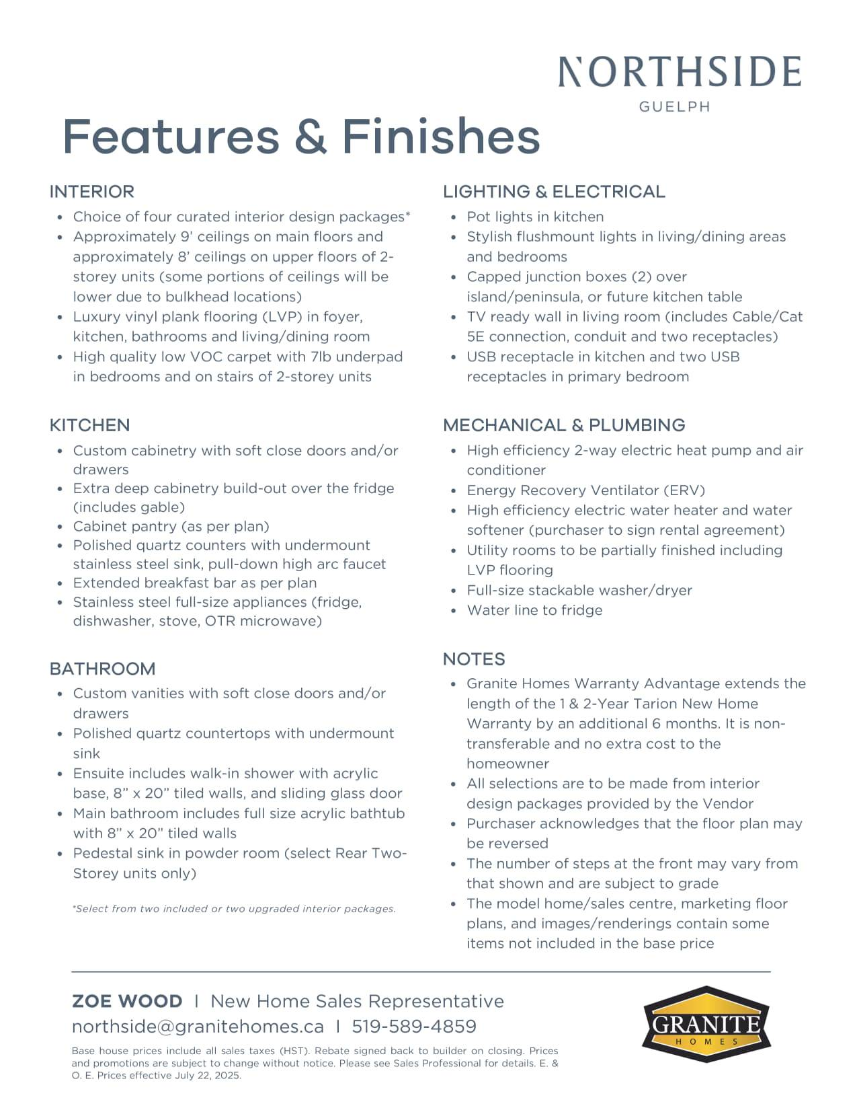
Schedule B(1) – Specifications

Schedule C(1) – Floor Plans

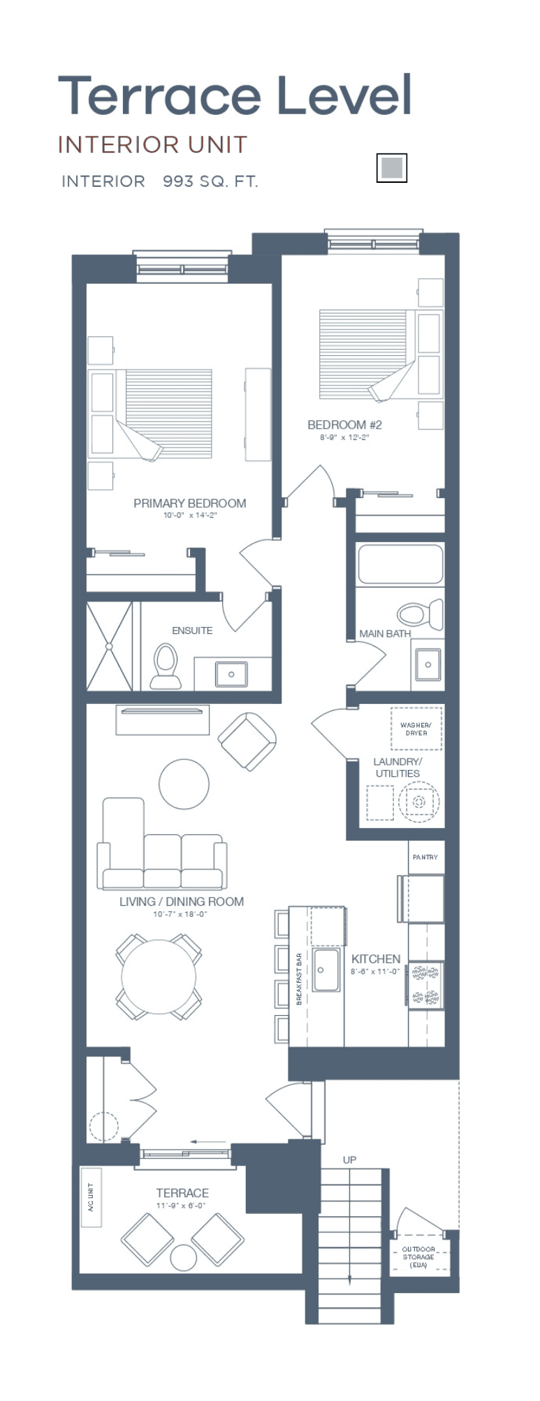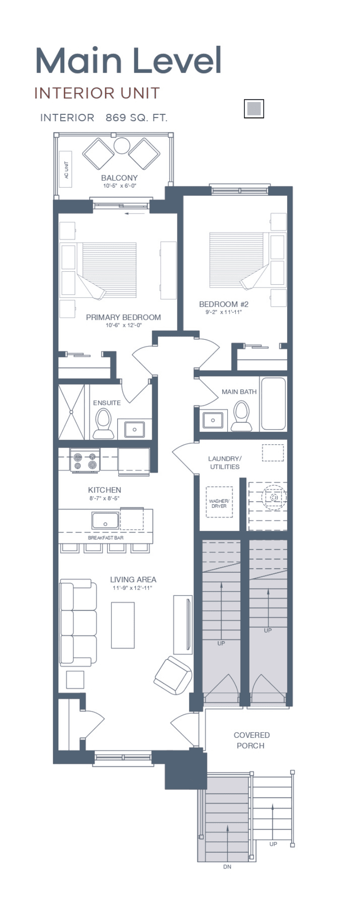

Schedule C(1) – Floor Plans

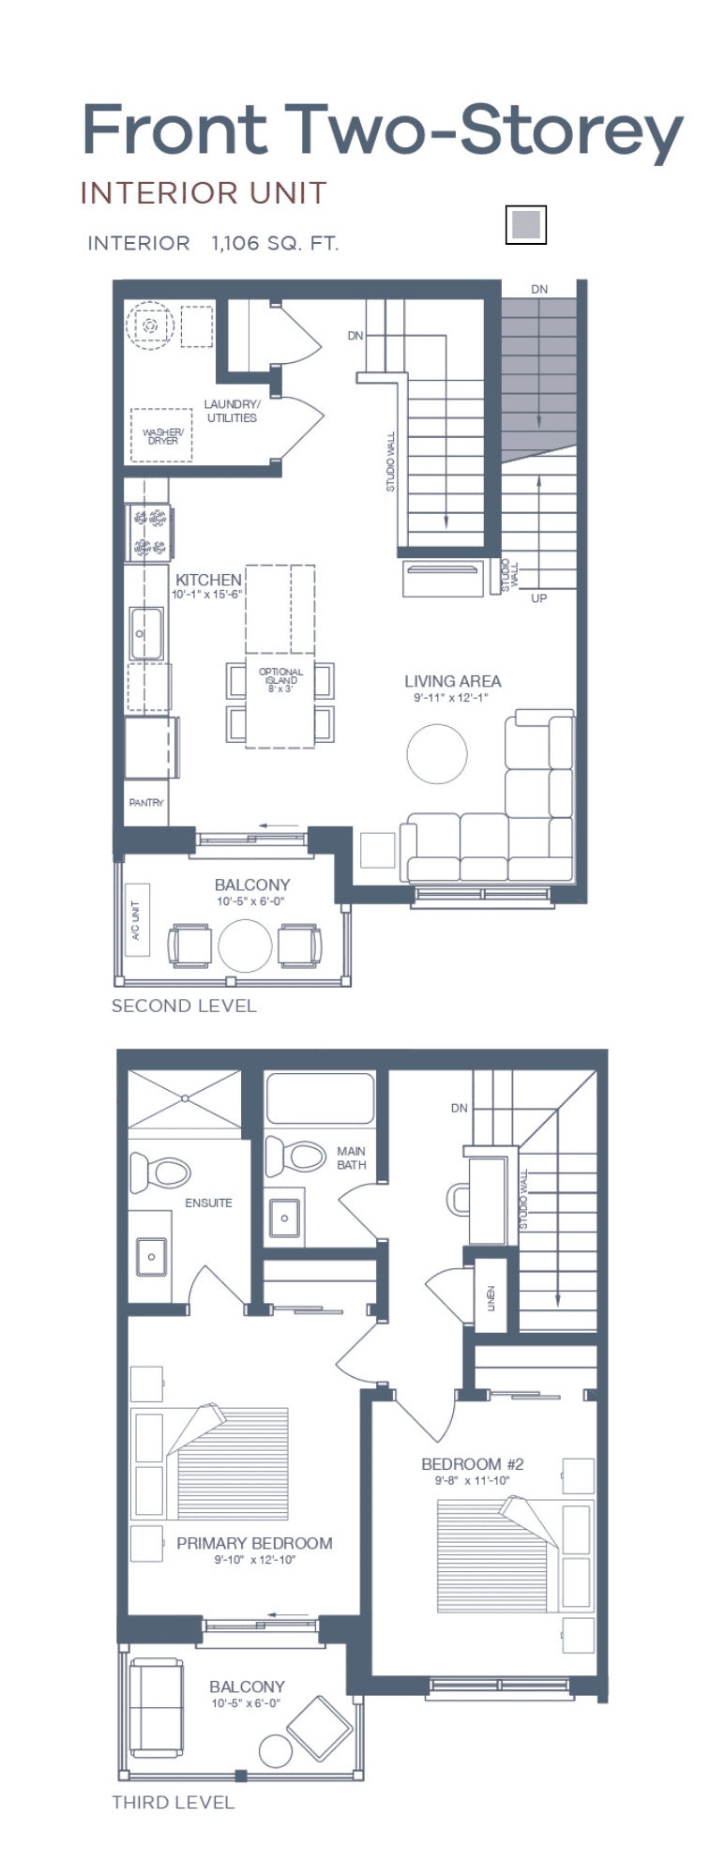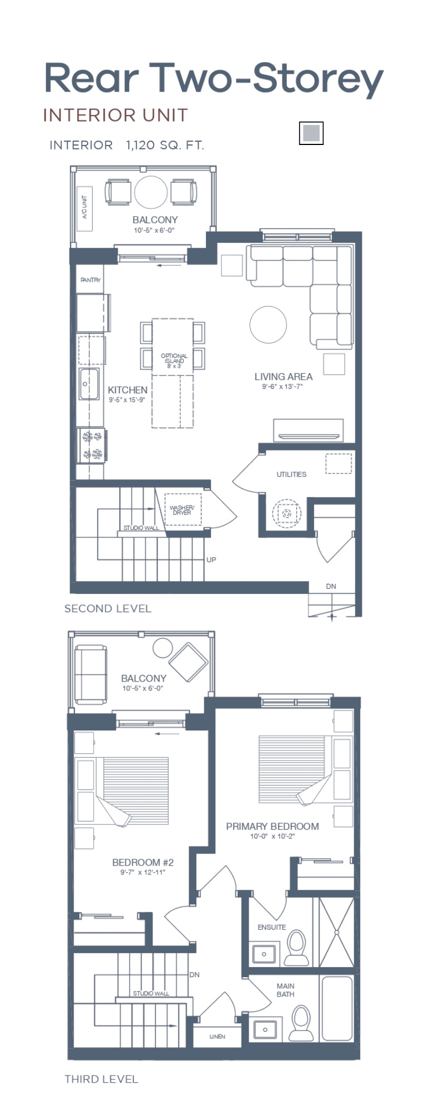

Schedule C(1) – Floor Plans

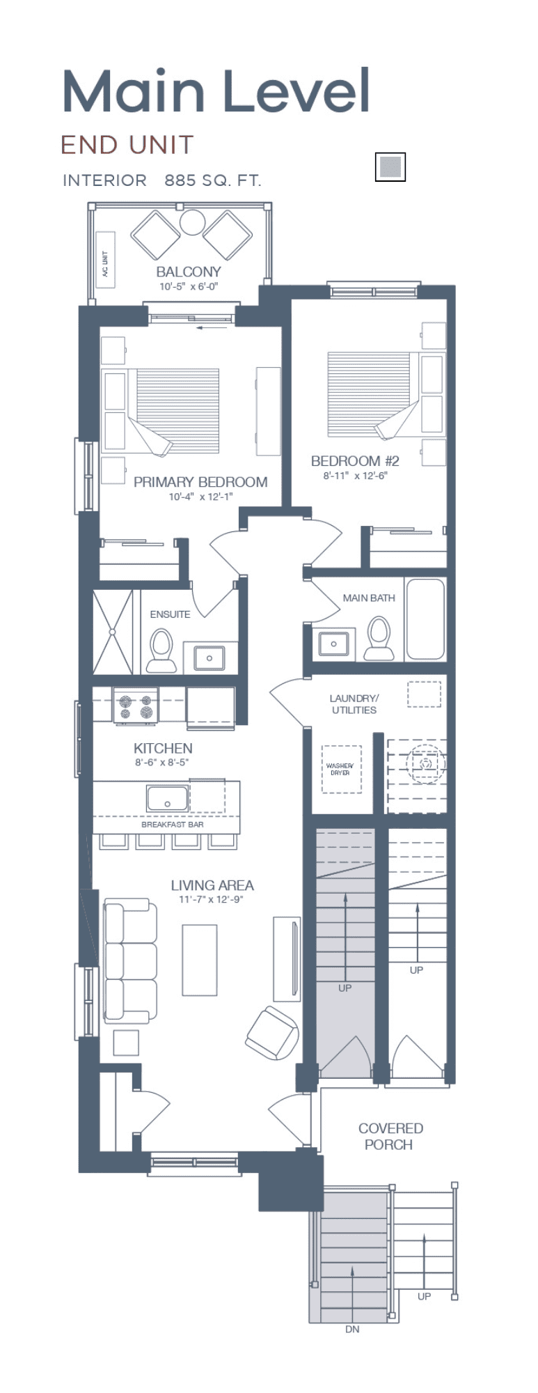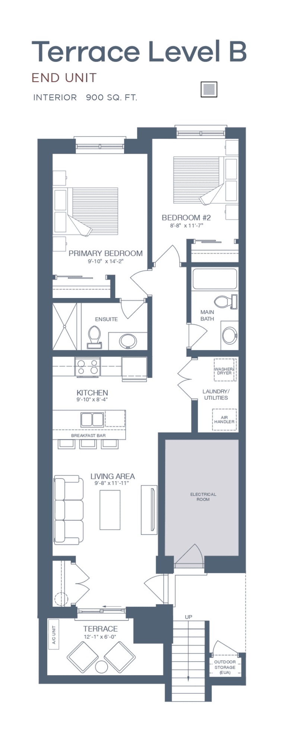

Schedule C(1) – Floor Plans

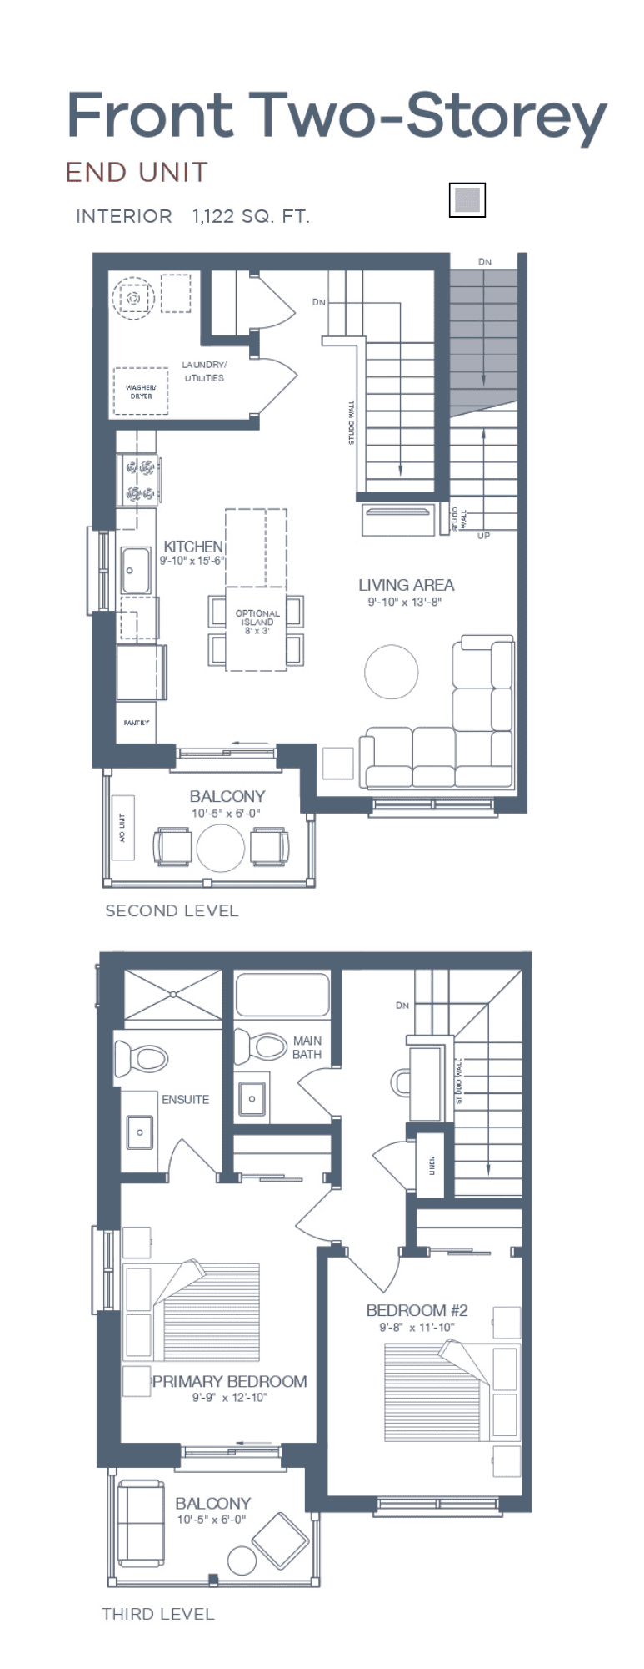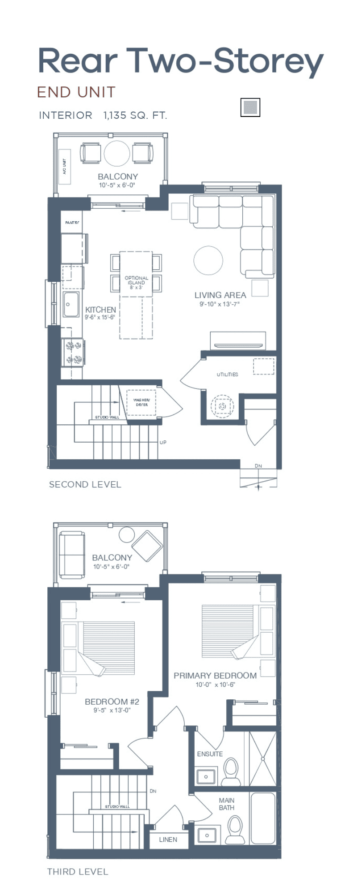

Schedule C(1) – Floor Plans

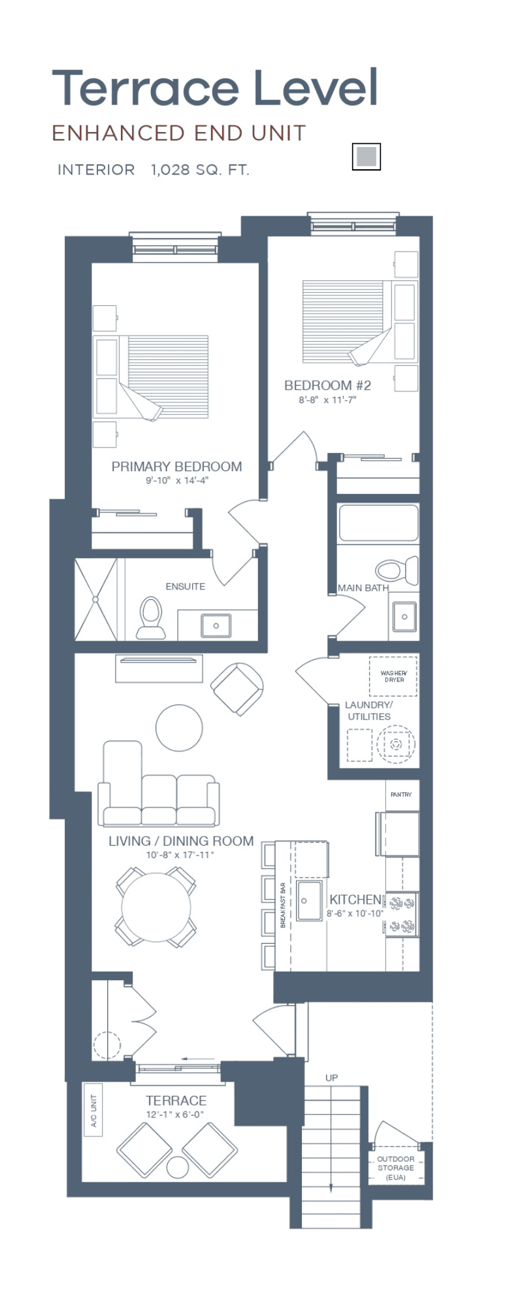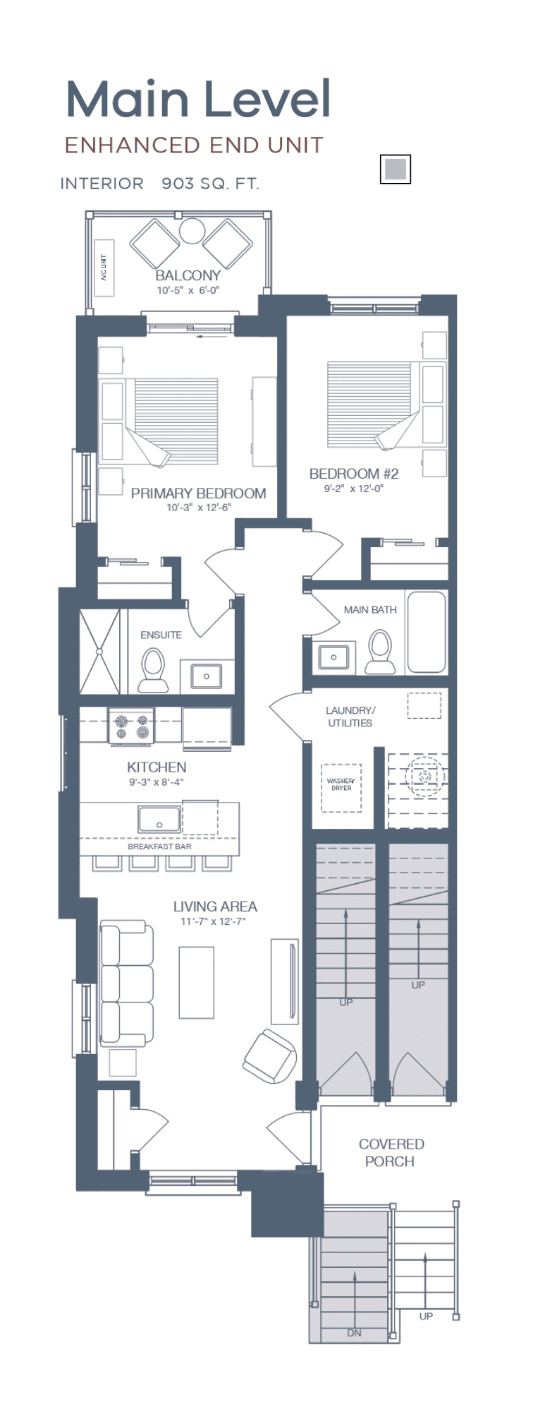
Schedule C(1) – Floor Plans

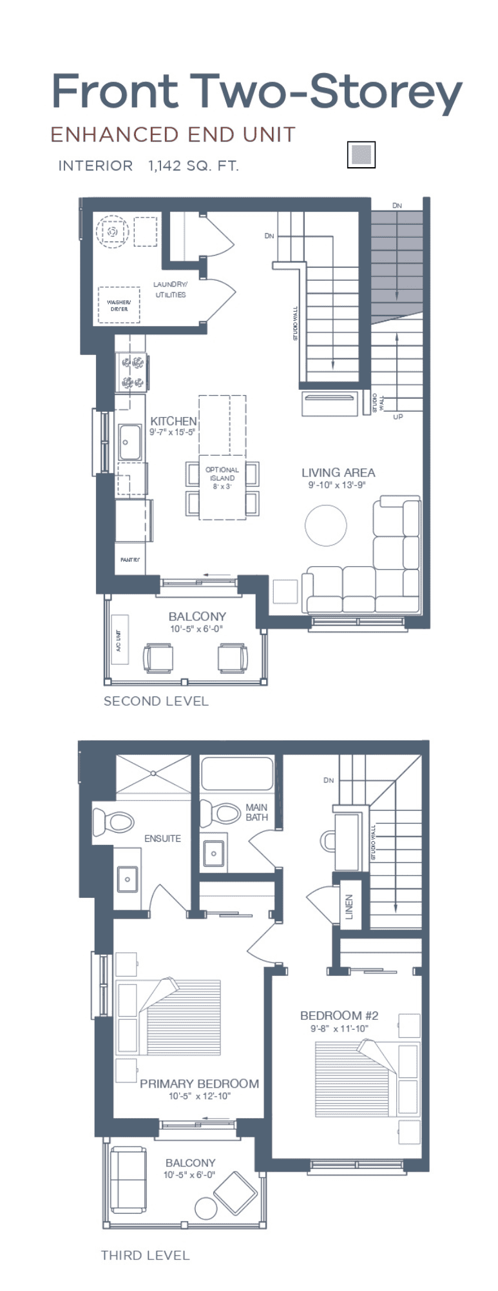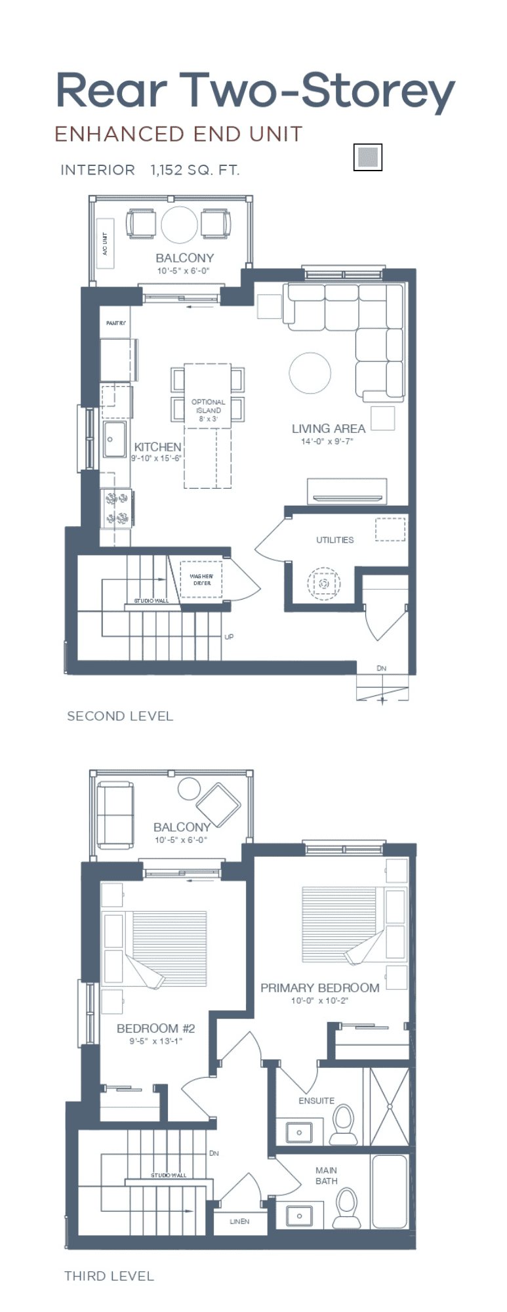

Schedule C(1) – Floor Plans

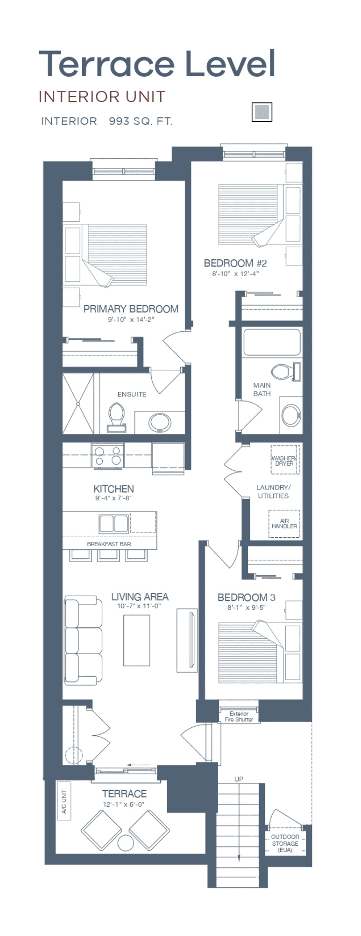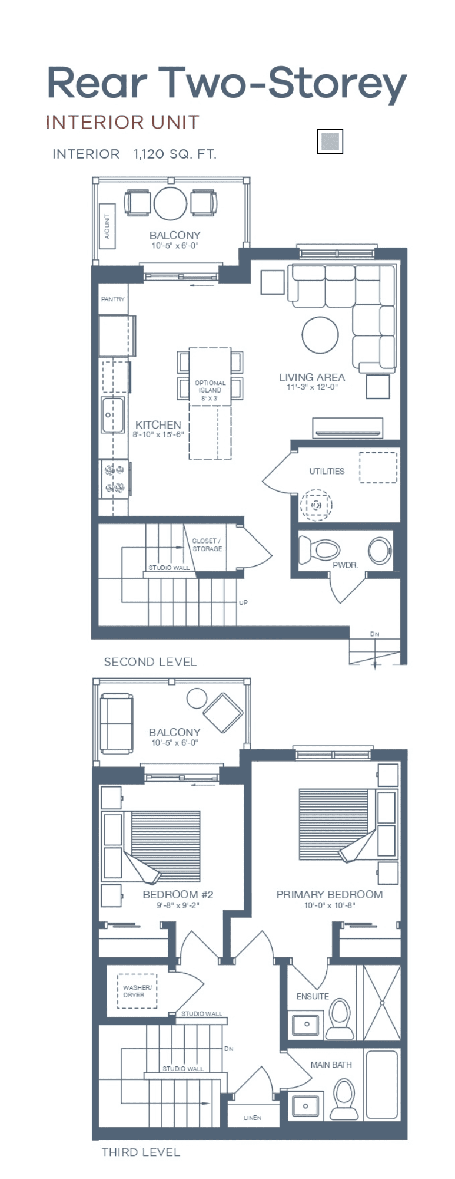
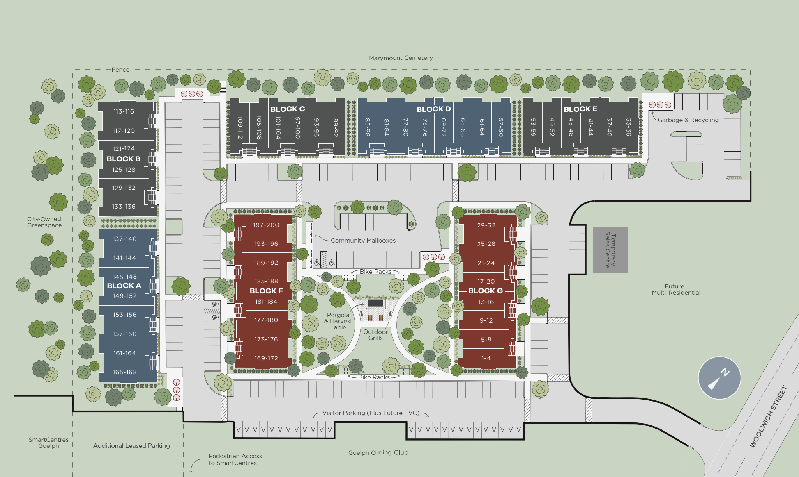
Schedule C2 – Site Plan



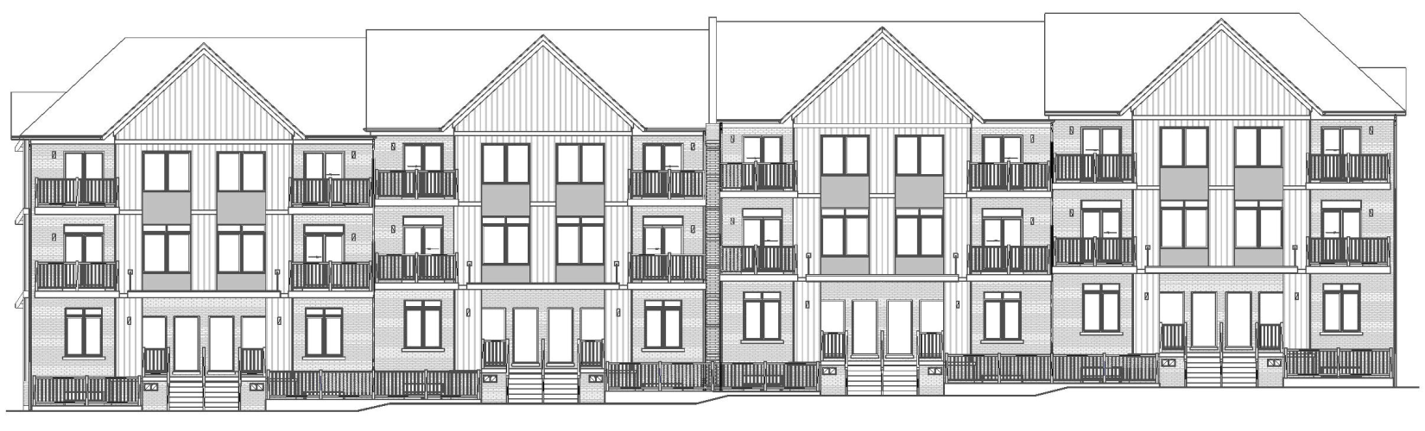
Block F
Block A
Schedule C3 – Elevations

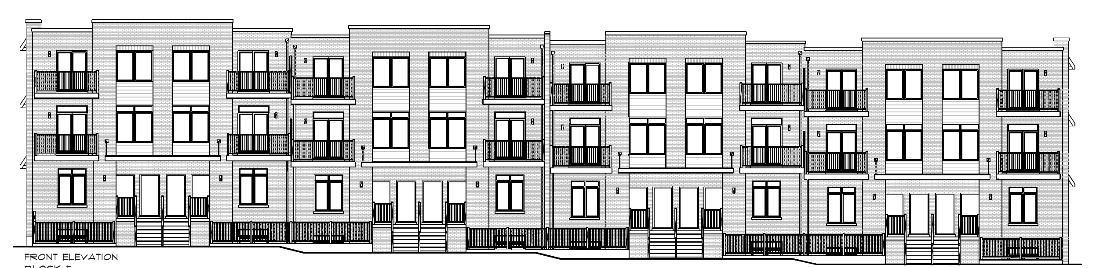

Schedule C3 – Elevations
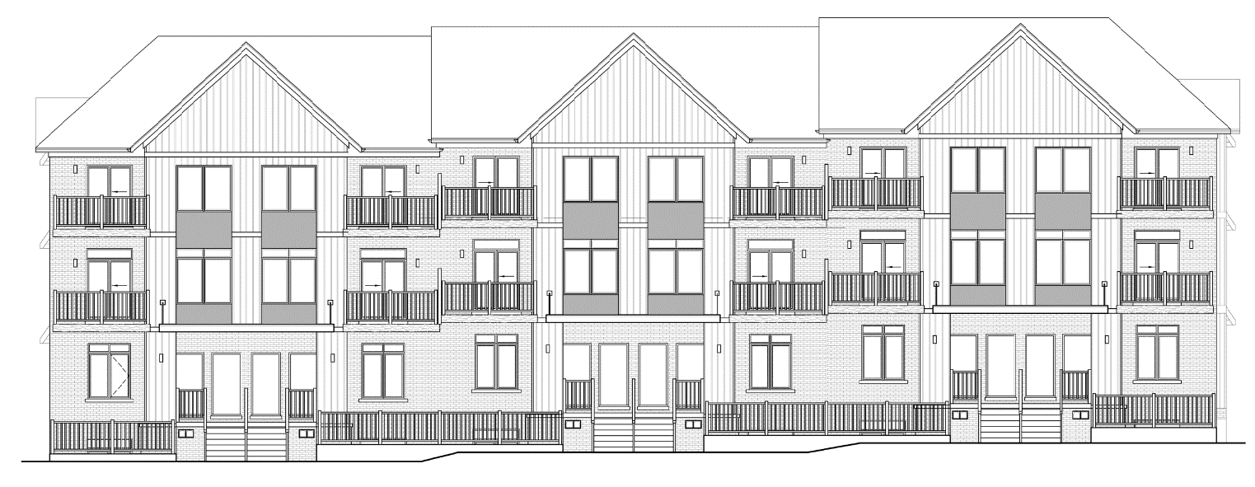

Block B

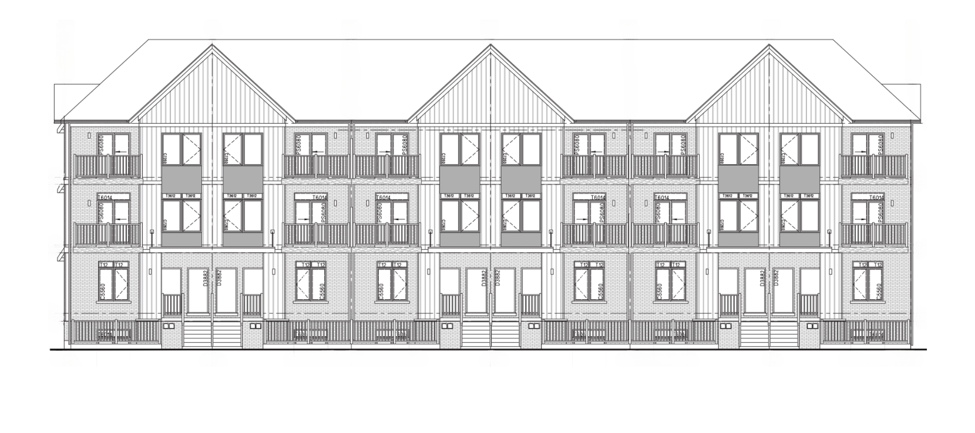
Block C

SCHEDULE D(1)

Construction Safety Policy

The safety of all individuals on our construction sites is of the utmost importance. It is understandable that homeowners wish to get a close view of their unit as it is being constructed. However, this is often an unsafe proposition. For this reason the Vendor requires that the Purchaser adheres to the following construction safety policy for the construction zone.

The construction zone shall be understood as being all areas beyond the curb of a publicly maintained road on which both active and inactive construction takes place. This is also to include the storing of construction-related materials.

The Purchaser acknowledges the importance of safety at the construction zone and for reasons of the Purchaser’s own safety agrees that at any time prior to Occupancy or Closing (whichever occurs first), the Purchaser:

- will not enter the construction zone during regular working hours or at any other time when active construction is taking place. Unscheduled visits to the construction site are not permitted due to safety and security reasons. Unscheduled visitors may be asked by the Vendor’s staff or security personnel to leave immediately;

- will hold harmless the Vendor for any injury or damages that may result from visiting the construction zone at any time;

- acknowledges that for safety reasons the Vendor recommends that the Purchaser never enters the construction zone other than those visits scheduled by the Vendor and accompanied by a representative of the Vendor;

- acknowledges that a construction zone is a dangerous place that is not appropriate for children or pets and the Purchaser will not bring children or pets to the construction zone at anytime; and,

- will wear the required safety equipment such as a CSA approved hardhat and CSA approved construction footwear during any visits to the construction zone.

The Purchaser is allowed one (1) scheduled visit with the Vendor to review the construction of the Unit, which visit (called a PDI) will take place just prior to the Firm Occupancy Date or Closing Date (whichever occurs first). The Vendor will determine the date and time for the scheduled visit in the Vendor’s sole and absolute discretion.

Visits otherwise permitted by this Schedule may not be allowed depending on the status of any restrictions imposed by any Government Authority on account of any pandemic or on account of health and safety practices of the Vendor, which health and safety policies may evolve and change from time to time.

The purpose of the scheduled visit is to review the inclusions in the Unit. It is not an opportunity to make changes (although changes may be considered by the Vendor) nor to show the Unit to family and friends.

By signing this Agreement, the Purchaser agrees:

- that if the Purchaser (or any of them if more than one (1)) suffers any injury or loss because of the contravention of the Purchaser (or any of them if more than one (1)) or anyone for whom the Purchaser (or any of them if more than one (1)) is responsible, of any of the foregoing policies that the Purchaser jointly and severally (if more than one (1)) completely releases, indemnifies and saves harmless the Vendor, the Vendor’s officers, directors, employees, workmen, agents and servants and their respective heirs executors, administrators, successors and assigns from and against any liability, costs, claims, damages, losses or expenses incurred on account of such injury or loss on account of such contravention; and

- in consideration of the payment to the Purchaser (or all of them if more than one (1)) of One Dollar ($1.00) by the Vendor (the receipt and sufficiency of which is hereby acknowledged) the Purchaser (or all of them if more than one (1)) agrees to having reviewed and understanding these policies and to strictly comply with the same.

SCHEDULE D(2)

Selections

This Schedule forms an integral part of the Agreement between these parties and to which it is attached.

If, after the Purchaser has selected colours or materials at the time of signing this Agreement, a selection becomes unavailable, the Vendor shall notify the Purchaser and the Purchaser agrees to reselect the selection within forty-eight (48) hours of being notified. If the Purchaser fails to make an alternate selection, the Vendor shall select an alternate colour or material on behalf of the Purchaser, in the Vendor’s sole discretion. If the Purchaser must re-select an item due to unavailability, the Purchaser agrees to pay any additional cost or receive a credit, if the cost of the item differs from the Purchaser’s original selection.

The Purchaser acknowledges that Artist Concepts attached herein may show options and extras which are not included in the Purchase Price. Notwithstanding anything herein contained to the contrary, the Purchaser acknowledges and agrees that if upon Closing any of the Extras ordered by the Purchaser remain incomplete in whole or in part and the Vendor has made reasonable attempts to complete said Extras, then at the Vendor’s option, there shall be a refund or credit to the Purchaser upon Closing of that portion of the amount paid by the Purchaser in connection with Extras allowable to those Extras which remain incomplete in whole or in part as aforesaid, as determined by the Vendor. The Purchaser further acknowledges that should the Vendor have the ability to complete said Extras within a reasonable timeframe shortly after Closing, the Purchaser and Vendor shall accommodate said completion. However, should aforesaid incomplete Extras remain incomplete beyond all reasonable attempts made by the Vendor to complete said Extras, the Purchaser acknowledges that a refund or credit shall prevail. The Purchaser further acknowledges and agrees that the amount so paid to the Purchaser (or for which, in the alternative, the Purchaser receives credit on the statement of adjustments) shall be accepted by the Purchaser as full and final settlement of any claim by the Purchaser with respect to the Extras which remain incomplete. Extras shall be limited to the return of the amounts referred to as aforesaid and thereafter there shall be no further liability upon the Vendor in connection with such incomplete extras and upon payment being made or credit being given, the Vendor shall be deemed to have been released from any and all obligations, claims or demands whatsoever, with respect to such incomplete Extras.

The Purchaser agrees that any request for changes requested by the Purchaser to the Unit may result in additional delays in the Occupancy or Closing of the transaction. Not to limit the generality of the foregoing, the Purchaser acknowledges that the Vendor shall not be required to make any change to the Unit unless the Vendor agrees in writing and, further, in the event that the Vendor makes any changes requested by the Purchaser, the Purchaser shall grant an extension of the Firm Occupancy Date or Closing Date, as applicable without compensation to the Purchaser, under the rules and regulations of the Addendum attached hereto, if requested by the Vendor. Due to the advance purchasing of materials and sub-trade notification, change orders after colour selections are complete will carry a Five Hundred Dollar ($500.00) plus H.S.T. administration fee plus the cost of the changes requested. It is also understood that if the Vendor cannot complete the change order, for whatever reason, the Vendor shall refund to the Purchaser the cost of that change order, or portion thereof and the Purchaser shall not be entitled to any other claim for damages.

SCHEDULE E(1)

Cooling-Off Period

- A Purchaser of a proposed or registered condominium unit may rescind the agreement of purchase and sale for the proposed or registered unit within ten (10) days from the later of the date the Purchaser receives the Disclosure Statement and related documentation and the date the Purchaser receives a copy of the agreement of purchase and sale executed by the Declarant and the Purchaser. If the agreement is rescinded the Purchaser is entitled to a return of all money paid on account of the purchase price of the proposed or registered Unit together with interest as prescribed by the Regulations to the Condominium Act, 1998 (the “Act”).
- If there are any material amendments to the Disclosure Statement, the Purchaser has a further ten (10) day period from receipt of the amended Disclosure Statement to rescind the agreement of purchase and sale and obtain a return of all money paid on account of the purchase price of the proposed or registered Unit together with interest as prescribed by the Regulations to the Act.
- Purchasers are urged to meet with their lawyer as soon as possible and before the expiry of the ten-day “cooling off” period to ensure they are fully advised of their rights and obligations with respect to their purchase. If any extension of the “cooling off” period is needed to obtain such advice, the Purchaser should enquire of the Vendor and seek a written extension of the period. In appropriate circumstances an extension of the “cooling off’ period may be allowed, but the Vendor is not obligated to grant it. The provisions of the Act that address the “cooling off” period are attached to the disclosure statement.

SCHEDULE G (1)
GENERAL PROVISIONS

DELIVERY OF DOCUMENTS
- Notwithstanding the delivery of the documents as required by the Vendor from the Purchaser, including, but not limited to, the HST Rebate Application Form, Affidavit for New Housing Rebate, and the Purchasers Covenants (if applicable), by fax or e-mail on the Closing Date, the Purchaser agrees, through the Purchaser’s solicitor, to provide the Vendor’s solicitor with the original copies of the aforementioned documents on the Closing Date or within two (2) Business Days after the Closing Date by personal delivery or courier if requested by the Vendor or the Vendor’s solicitor.
NO ASSIGNMENT, DEATH OF PURCHASER, INSOLVENCY
- This Agreement is personal to the Purchaser and is non-assignable by the Purchaser, unless otherwise specified pursuant to an assignment schedule attached hereto, and then only in accordance with the terms of such schedule. The Purchaser agrees not to sell, mortgage, deal with or in any way encumber the Unit, directly or indirectly, nor permit any lien or conditional sales agreement to be registered with respect thereto and will not obstruct or alter the Unit before or after Closing until the full amount of the funds, mortgage or otherwise, have been advanced to the Vendor and the Vendor has received the full Purchase Price and the Purchaser has registered the transfer/deed of land. For the purposes of this provision “sell” shall include list for sale, advertise for sale or the entering into an agreement of purchase and sale. Upon any breach of this provision which may occur before Closing, in addition to any other remedies the Vendor may have, this Agreement may be declared null and void at the Vendor’s option and the deposit money shall be retained by the Vendor as liquidated damages and not as penalty.

- In the event of the death of a Purchaser, the Vendor may terminate this Agreement by returning the monies paid hereunder (inclusive of monies paid for Extras) to the estate of such Purchaser or the Purchaser’s solicitor without interest or deduction within thirty (30) days of being advised in writing of or otherwise ascertaining the death of the Purchaser. In the absence of termination pursuant to this clause on account of the death of a Purchaser, the estate thereof shall remain bound by this Agreement.

- In the event of the insolvency or bankruptcy of a Purchaser, the Vendor may terminate this Agreement by notice to the Purchaser or the Purchaser’s solicitor and upon such notice being given the deposits and all monies paid by the Purchaser to the Vendor are forfeit to the Vendor and this Agreement is at an end.

Where the Purchaser is a corporation, the Purchaser agrees that any direct or indirect change of control of the Purchaser (whether by transfer or issuance of shares in the capital of the Purchaser or otherwise) shall constitute a prohibited transfer or assignment hereunder and shall trigger the remedies of the Vendor for the Purchaser’s default including those set out herein.
CHANGES
- The Vendor may, subject to the requirements of the Ontario New Home Warranties Plan Act/Tarion Warranty Corporation, from time to time in the Vendor’s discretion or as required by any governmental authority or any mortgagee, change, vary or modify the plans and specifications pertaining to the Unit (including architectural, structural, engineering, landscaping, grading, mechanical, service or other plans) from the plans and specifications existing at the inception of the Project or as they exist at the time the Purchaser entered into this Agreement, or as same may be illustrated on any scale models in the sales office, marketing materials and/or plans or otherwise. The Purchaser shall have no claim against the Vendor for any such changes, variances or modifications nor shall the Purchaser be entitled to notice thereof. This includes, but is not limited to, any changes to elevations or floor plans that may be required by any governmental authority and/or pursuant to any Building Code requirements. The foregoing is subject to the proviso that the changes must attempt, to the extent reasonably possible, to maintain the overall concept of the development as presented to the Purchaser.

- Subject to the requirements of the Ontario New Home Warranties Plan Act/Tarion Warranty Corporation, the Vendor may substitute other materials in the construction of the units and common elements of the Condominium Plan from those provided for in the plans or specifications, provided that any such substitutions shall be of the similar quality (as determined by the Vendor acting reasonably) as the original specified materials.

- The Purchaser acknowledges that any finishes, materials and/or layout that the Purchaser may have observed in the Vendor’s promotional literature, a model home and/or the Vendor’s sales office, was constructed or created in isolation and does not necessarily accurately represent the appearance of the Unit to be constructed by the Vendor. The layout of a unit that the Purchaser may have observed in the Vendor’s promotional literature, a model suite, and/or the Vendor’s sales office may be the reverse of the Unit purchased. The Purchaser agrees and acknowledges that the finishes, materials and/or layout of the Unit may differ from that which may have been viewed by the Purchaser in the Vendor’s promotional literature, a model home and/or the Vendor’s sales office and the Purchaser waives all claims against the Vendor that relate to any such difference provided the Unit is constructed and completed in accordance with the provisions of this Agreement.
TARION WARRANTY CORPORATION AND INSPECTIONS
- The Vendor represents and warrants that the Vendor is registered with the Home Construction Regulatory Authority and under the TARION Warranty Corporation (the “Program”), as applicable, and that the Unit is or will be enrolled under the Program. The Vendor agrees to make available, and the Purchaser agrees to meet with, a representative of the Vendor not less than twenty-four (24) hours prior to the Firm Occupancy Date to inspect the Unit and to verify that the Unit has been completed in accordance with the provisions of this Agreement. In the event that any items remain incomplete at the time of such inspection, only such incomplete items shall be listed by the Vendor on the form of Certificate of Completion and Possession and pre-delivery inspection form (collectively referred to as the “Certificate”) under the Program. The Purchaser covenants to execute the Certificate, which Certificate, upon execution by the Vendor and Purchaser, shall constitute the Vendor’s only undertaking to complete any such outstanding items. The Purchaser agrees that such incomplete items as are included in the Certificate represent the balance of work to be completed by the Vendor and the Purchaser agrees that no further requests for supply or completion may be maintained by the Purchaser and this shall serve as a good and sufficient release of the Vendor in that behalf. All items so listed shall be completed or rectified within a reasonable time after Closing. The Purchaser agrees that the Purchaser shall not hold back or request that there be held back from the balance due on Closing any funds for unfinished work or any other purpose whatsoever. The Purchaser agrees that in no event shall the Purchaser be entitled to obtain possession of the Unit until and unless the Purchaser has executed the said Certificate. The Purchaser should visit the Tarion Learning Hub for more information about the warranties related to their Unit: https://www.tarion.com/homeowners/homeowner-resources-hub.

- If the Purchaser and/or the Purchaser’s designate fails to attend the pre-delivery inspection or fails to execute the Certificate at the conclusion of the pre-delivery inspection, the Vendor may declare the Purchaser to be in default under this Agreement and may exercise any or all of the Vendor’s remedies set forth in this Agreement and/or at law. Alternatively, the Vendor may, at the Vendor’s option, complete the within transaction but not provide the keys to the Unit to the Purchaser until the Certificate has been executed by the Purchaser and/or the Purchaser’s designate or complete the within transaction and the Vendor may complete the Certificate on behalf of the Purchaser and/or the Purchaser’s designate and the Purchaser hereby irrevocably appoints the Vendor as the Purchaser’s attorney and/or agent and/or designate to complete the Certificate on the Purchaser’s behalf and the Purchaser shall be bound as if the Purchaser and/or the Purchaser’s designate had executed the Certificate.

- The Project, Unit and Property have the benefit of the warranties established pursuant to the Ontario New Home Warranties Plan Act/Tarion Warranty Corporation. As a result, no further warranty or guarantee is given. Apart from the warranties set out above, there is no express or implied: (1) condition, (2) warranty, (3) guarantee, (4) representation or term with respect to any matter including, without limiting the generality of the foregoing, the design or engineering or construction (including quality of materials) of the Unit, the Property, or the Project. The Vendor gives no warranty or guarantee with respect to any appliances conveyed by it to the Purchaser. The Vendor hereby assigns and transfers to the Purchaser all assignable manufacturers’ warranties, if any, with respect to the Extras and fixtures if any. No further proof of this assignment shall be required or given on the completion of this transaction.
RIGHT OF ENTRY
- The Purchaser agrees that Municipal Building Inspectors may enter the Property and obtain reasonable access to the Unit at any time after occupancy to inspect the construction and mechanical systems pursuant to the Building Code. Acceptance of construction, siting and grading by the Municipality, the mortgagee, or Tarion Warranty Corporation, where applicable, shall conclusively constitute acceptance by the Purchaser. The failure or refusal of the Purchaser to permit access to the Unit, following reasonable notice by any such Municipal Building Inspector or the Vendor, shall relieve the Vendor of any obligation to complete or rectify any items of work outstanding or pursuant to any work order.
- The Vendor has the right to enter the Unit and any exclusive use portion of the common elements after the Firm Occupancy Date and Closing to complete any work or to do warranty work and/or as required in order to comply with any municipal or government requirement with respect to the Unit, including without limiting the generality of the foregoing, anything required to be done on account of any subdivision or other municipal agreement or requirement. In addition this right of entry includes the right of entry to make inspections or to do any work or repairs thereon or therein which may be deemed necessary by the Vendor in connection with the completion, rectification or servicing of anything in or forming part of the Unit or any other unit or portion of the common elements.
- Any of the Vendor’s work that is not complete by the Firm Occupancy Date will be completed as soon as reasonably possible thereafter.
- The Vendor is entitled to make use of and to operate any appliance or fixture (including without limiting the generality of the foregoing, any heating and/or cooling equipment servicing the Unit) during the construction of the Unit until the earlier of the Firm Occupancy Date or the Closing Date without the Vendor having any obligation to pay any compensation to the Purchaser or make any repair on account thereof including for any minor scratches/dents and other cosmetic damage provided the same do not impair the function of the appliance, fixture, or heating and/or cooling equipment. Any such use by the Vendor does not give rise to any right in favour of the Purchaser to require the repair or replacement of any such appliance, fixture, or heating and/or cooling equipment provided the same does not impair the function of the appliance, and any such appliance, fixture or heating and/or cooling equipment so used shall still be considered as “new” for the purposes of this Agreement.
GRADING
- The Purchaser, and the Purchaser’s heirs, executors, administrators, successors and assigns agree that the Purchaser will not alter the grading or change the elevation or contour of the Property except in accordance with the provisions of the Creating Documents and drainage plans approved by the Municipality and will permit the developer/subdivider, Vendor or the Municipality to enter onto the Property for the purpose of checking grades, levels, and elevations, and when necessary, altering such grade, levels and elevations. The Purchaser agrees to adhere to the overall drainage patterns of the Property which includes the Unit, including such easements as may exist, or may be required for the purpose of water drainage to and from adjoining lands and the Purchaser agrees to grant such easements as may be required from time to time for drainage purposes. The foregoing covenants may be included in any conveyance in respect of the Unit. Any breach of the above promise which requires rectification may be carried out by the Vendor or the subdivider at the sole expense of the Purchaser payable forthwith upon demand.

- The Purchaser agrees not to install any foundation planting within six (6) feet of any external wall or to finish the whole or any part of the basement of the dwelling, if applicable, for a period of twelve (12) months after Closing, regardless of if this is to be allowed pursuant to the provisions of the Creating Documents. A breach of either of the above terms relieves the Vendor of any obligation to rectify any deficiency resulting from aforesaid breach in basement water leakage or seepage but does not release the Vendor from rectifying unrelated basement or foundation deficiencies.

- The Purchaser accepts that the Vendor will only provide steps to grade from the front entrance and entrance from garage (if the Unit includes a garage) to the Unit. All other steps to grade are the sole responsibility of the Purchaser. In addition, basement window placement (if the Unit includes a basement) may be moved at the discretion of the Vendor without notice due to grade and/or other construction related conditions.
NO WARRANTY ON PARGING
- The Purchaser acknowledges that parging is strictly a cosmetic item and is not a requirement of the Ontario Building Code and therefore the Vendor is not obligated to provide such application. Parging has a tendency to crack and dislodge from the foundation and the Purchaser acknowledges that any parging application will not be a warrantable item and the Purchaser will be solely responsible for any and all service issues related to the parging.

DAMAGES BY PURCHASER
- The Purchaser covenants and agrees to reimburse the Vendor for any amount which the Vendor may be obliged to pay for damage caused by the Purchaser, or by those for whom the Purchaser is in law responsible, to any services installed within the Project that contains the Property, which services shall without limitation include survey stakes, landscaping, trees, curbs, streets, roads, sidewalks, street signs, street lighting, sanitary and storm sewers and any underground services installed by or on behalf of any public or private utility.
TITLE
- The Purchaser agrees to accept title to the Unit and the Property subject to the following items, if applicable, and Purchaser covenants and agrees to adhere to the terms and conditions as set out therein. Purchaser shall satisfy the Purchaser’s self as to compliance with any of the agreements, restrictions, covenants or matters set out herein, if applicable, and Vendor shall not be obligated, on Closing or thereafter, to obtain a release or compliance certificate of any of the said agreements, restrictions, covenants or matters:

  - any subdivision agreements, development agreements, site plan agreements, certificates of property use, lot drainage and occupancy agreements or other agreements now or hereafter entered into with any municipal or governmental authority or any public or private utility including any restrictions contained therein registered on or affecting title to the Unit, the Project, and/or the Property;
  - any building or other stipulations, restrictions, provisions, covenants, records of site condition or certificates of property use that may now or hereafter be registered against title to the Unit and/or the Property, including any restrictions attached hereto or included in the transfer to the Vendor, if applicable;
  - any Section 98 Group Indemnity Agreement under the Act, Mutual Use and/or Cost Sharing Agreements or the like that may now or hereafter be registered on title to the Unit and/or the Property;
  - any regulations and restrictions of any conservation authority;
  - any right in the nature of an easement or license for the Vendor and/or the developer, the Municipality or other government authority, public or private utilities, their respective successors and assigns and servants or agents to enter upon the Unit and/or the Property for completion of grading and surface drainage and/or installation of catch basins and in order to permit the Vendor and/or developer to carry out the obligations under any agreement or as imposed by any governmental authority or bonding company to the effect any corrective measures with respect to any drainage assessment applicable to the Unit, Property, and/or Project;
  - such easements or rights-of-way or licenses, permanent or temporary, as now exist or may subsequently be granted in favour of the Municipality, the developer, or any public utility for services or utilities, including installation and repair of coaxial cable; and,
  - such easements as may be required by adjoining land owners for maintenance or encroachment purposes and the encroachments permitted thereby.
- The Vendor shall not be obligated to obtain nor register on title any releases of any personal property security registrations, easements, licenses, agreements, restrictions, covenants, conditions or obligations or provide any proof of compliance with same. The Purchaser will accept title subject to same.
- On Closing the Purchaser will accept the Vendor’s solicitors’ unconditional and unqualified undertaking to discharge any mortgages (whether institutional or private as such terms are defined in the Law Society of Ontario Guidelines) or security interests registered against the title to the Unit, any chattels or fixtures and/or Property as soon as reasonably possible after closing. This does not obligate the Vendor or the Vendor’s solicitor to provide any undertaking or release of an agreement with any Municipality or governmental authority. The Vendor’s solicitor may, at their option, elect to deliver the above undertaking to the Purchaser’s solicitor via regular mail, e-mail, facsimile, and/or by making it available for download from an Internet location. The Purchaser agrees that delivery of the undertaking to the Purchaser’s solicitor in any one (1) of the above mentioned manners constitutes good and sufficient delivery of same.
- The Purchaser shall not call for the production of any title deeds or abstracts of title, occupancy permit(s), grading or other certificates, survey, sketch or other proof or evidence of title, nor have furnished any copies thereof apart from the description plans of the Condominium Plan.
- The Unit is being constructed in a new development. The title to the Unit will be subject to at least one (1) and possibly more agreements with a municipality, conservation authority, or other person or company. These agreements will remain on title after Closing and will not be released by the Vendor. The title may also be subject to building restrictions and/or a building scheme imposed by the subdivision developer and/or the Vendor which may be attached hereto as a Schedule. The Vendor will not provide proof of compliance with or obtain a release of any such agreements or restrictions. The Purchaser agrees to be bound by any such agreements and restrictions/building scheme and acknowledge and agree to accept title subject to such modifications to the said restrictions/building scheme as may be required by the project developer.
TITLE SEARCH
- The Purchaser shall be allowed until (and including) the fifth (5th) day prior to Closing to examine the title to the Unit at the Purchaser’s expense and if, within that time, any valid objection is submitted to the Vendor’s solicitor in writing, which the Vendor is unable or unwilling to remove and which the Purchaser will not waive, this Agreement shall be null and void, notwithstanding any intermediate acts or negotiations in respect of such objections, and the Purchaser’s deposits shall be returned by the Vendor without interest and neither the Vendor nor any of the Vendor’s agents shall be liable to the Purchaser for any further costs or damages. Save as to any valid objections made within the time limited herein, the Purchaser shall be deemed conclusively to have accepted the title of the Vendor to the Unit. Nothing shall permit the Purchaser to insist on completion of this transaction with any abatement of the Purchase Price.
NOISE AND OTHER WARNING CLAUSES
- The Purchaser agrees to accept title subject to any noise and/or other warning clauses to which the Unit may be subject on account of the Unit’s proximity to some external location and/or with respect to noise emanating from abutting properties, and/or street or other streets in the area or from any other cause, or as may otherwise be required by the relevant Municipality. It is possible that the Municipality and/or the approval authority may require additional or amended noise or other warning clauses as a condition of draft condominium plan approval or draft site plan approval, or that such requirements may arise out of one (1) or more studies required by such conditions. If any additional or amended noise or other warning clauses are so required, the Vendor shall include the same in an amendment to this Agreement and provide such amendment to the Purchaser who shall execute and return the said amendment to the Vendor within seven (7) Business Days of the receipt of such amendment by the Purchaser. Regardless of whether or not the Purchaser executes and returns any such amendment the provisions set out therein are irrevocably agreed to be an amendment to this Agreement and deemed to be part hereof.
- The Purchaser specifically acknowledges and agrees that the proximity of the Unit to any nearby roadways, highways, subways (and corresponding transit operations) and/or railway tracks and lines (corresponding railway operations, over which railway traffic may travel), as well as any nearby residential, industrial, commercial/retail or office buildings, any nearby public park (which may or may not contain playground facilities for children), and/or any nearby hydro sub-station or hydro corridor, may result in noise and/or vibration transmissions to (or otherwise affecting) the Unit or any portion thereof, and may cause the noise exposure and/or vibration levels affecting the Unit to exceed the noise/vibration criteria established by the Municipality and/or approval authority, and that despite the inclusion of noise control features within the Project, noise levels and vibration from any of the aforementioned sources may continue to be of concern, occasionally interfering with some activities of the Unit occupants.
- In addition to the above-listed sources of noise in the paragraph above, the Purchaser is hereby advised that:
  - as and when other units (and/or exclusive use common elements areas) in the Project are being completed and/or moved into, excessive levels of noise, vibration, dust and/or debris are possible, and the same may accordingly temporarily cause noise and inconvenience to Unit occupants;
  - on Closing (and even for some period of time after Closing), there still may be outstanding construction and/or finishing work to be undertaken by the Vendor to portions of the existing exterior and/or interior of the Project, which may require the continued placement and use of an exterior hoist (for hauling or conveying construction materials, workers and/or debris) that is temporarily anchored to the exterior façade of a building, immediately outside of or near the Unit, which in turn may give rise to an increase in noise and/or vibration levels during construction hours (between 7:00 a.m. and 7:00 p.m.), pending the completion of all construction and finishing work in respect of the Project, which noise and/or vibration may be of concern to the Purchaser and which may interfere with some activities of the Unit occupants; and
  - the construction of any future phase of the Project in or on the Property may give rise to an increase in noise and/or vibration levels during construction hours (between 7:00 a.m. and 7:00 p.m.).
- It is expressly understood and agreed that the Purchaser shall not make or pursue any claim against the Vendor (or any other party) for compensation, for an abatement in the Purchase Price and/or for damages or otherwise, nor initiate or pursue any claim, action or proceeding against the Vendor (or any other party) by reason of any or all of the foregoing concerns regarding noise and/or any inconvenience or injury to the Purchaser (or the Purchaser’s property) caused thereby.
TENDER ON CLOSING
- Notwithstanding anything contained in this Agreement to the contrary, it is expressly understood and agreed by the parties hereto that an effective tender shall be deemed to have been validly made by either party (in this paragraph called the “Tendering Party”) upon the other party (in this paragraph called the “Receiving Party”) when the solicitor for the Tendering Party has:
  - delivered all applicable closing documents and/or funds to the Receiving Party’s solicitor in accordance with the provisions of this Agreement and the DRA Schedule. In lieu of actual delivery of funds to the Receiving Party’s solicitor the Tendering Party may, pursuant to one (1) of the methods of delivery set out above, provide the Receiving Party’s solicitor a statutory declaration of the Tendering Party’s solicitor that states without qualification that the said solicitor is in possession of all funds necessary to complete the transaction and the said funds are in such solicitor’s trust account not subject to any hold imposed thereon by the solicitor’s or any other bank and are immediately available to be delivered on the Closing Date to the Receiving Party’s solicitor as required to complete the transaction;
  - advised the solicitor for the Receiving Party, in writing, that the Tendering Party is ready, willing and able to complete the transaction in accordance with the terms and provisions of this Agreement; and,
  - has completed all steps required by the Teraview Electronic Registration System (“TERS”) in order to complete this transaction that can be performed or undertaken by the Tendering Party’s solicitor without the cooperation or participation of the Receiving Party’s solicitor, and specifically when the Tendering Party’s solicitor has electronically “signed” the Transfer/Deed of Land for “completeness” (but not for “release”) and granted “access” to the Receiving Party’s solicitor (as each of those terms are understood within TERS);
without the necessity of personally attending upon the Receiving Party or the Receiving Party’s solicitor with the aforementioned documents and/or funds, and without any requirement to have an independent witness evidencing the foregoing.
LAND REGISTRY OFFICE DISRUPTION OR DELAY
- If, on the Closing Date:
  - the Land Registry/Land Titles Office or its staff are unable or unwilling to process and register the closing documents that are required to be registered on account of this transaction or having started the registration process on account of this transaction and are unable or unwilling to complete the same on such day and/or if the electronic registration system is not available or operational; or
  - Land Registry/Land Titles Office, its staff and/or any of the Vendor’s or Purchaser’s solicitor are unable to process and register the closing documents that are required to be registered on account of this transaction due to delays in the Land Registry/Land Titles Office’s completion of documentation procedures that prevent Closing on the Closing Date including but not limited to:
    - the Property Identifier Numbers (“PINs”) for the Property having not been created/assigned within five (5) days after the registration of the declaration or amendment as the case may be; or
    - any documents registered by the Land Registry/Land Titles Office having not been uploaded into the Teraview system within five (5) days after the registration of the declaration or amendment as the case may be.
then, in such event, the Vendor has the right to extend the Closing until after the said Land Registry/Land Titles Office staff is able and willing to register such documents or the electronic registration system is available and operational as the case may be with all adjustments being made at the option of the Vendor either as of the original Closing Date or the actual date of completion of this transaction.
ELECTRICITY USE FOR CONSTRUCTION ON ADJACENT LOTS
- The Purchaser agrees to allow the Vendor and/or the Vendor’s assignees the use of electricity from the Unit after closing for construction purposes on adjacent parts of the Project. The Builder will subsequently provide the Purchaser with a Seventy-Five Dollar ($75) flat rate reimbursement in exchange for said electricity use if same is required. This electricity use will typically be required from time to time for approximately two (2) months until electrical services are installed on the part of the Project under construction. Allowing the Vendor and/or the Vendor’s assignees to plug into an exterior electricity receptacle allows the Vendor and/or the Vendor’s assignees to avoid the use of noise and air pollution causing generators.
MODEL HOMES AND ADVERTISING
- The Purchaser agrees that until all units in the Project are sold, the Vendor shall have the right to maintain model homes, signs, sales staff and promotional material in the Project and to show prospective purchasers through the Project and through any unsold units. The Purchaser acknowledges that all models, unsold units, and occupied units available for viewing may contain options and extras, including be not limited to: hardwood flooring, light fixtures, furnishings, paint, wallpaper, pickets, upgraded cabinets and broadloom, and decor furnishings, which are not included in the Purchase Price of said Unit. The Purchaser allows the Vendor to use any image of the Unit for advertising and promotional purposes without compensation.

- The Purchaser shall not interfere with the completion by the Vendor of the Property or other proposed units.
DOCUMENTS AND SERVICES
- This Agreement is a personal agreement between the parties and creates no interest in the Project, Unit, Property, or Extras and as a result does not give rise to a “purchaser’s lien” in favour of the Purchaser. The Purchaser agrees not to register or deposit this Agreement (or notice of this Agreement), a caution or any other instrument or document of any kind whatsoever against title to the Project, Unit or Property prior to completion on the Closing Date as this would obstruct mortgage advances, prevent registration of municipal and other agreements and cause substantial damage to the Vendor and other purchasers by delaying registration of the Creating Documents. If the Purchaser breaches this provision, the Purchaser is in default pursuant to this Agreement and will immediately sign and provide whatever documentation is required to remove the instrument or deposit from title to the Project, Unit, and/or Property.
NOTICE
- Any notice required to be given pursuant to this Agreement to the Purchaser shall be deemed to have been given if personally delivered, sent by facsimile transmission (“fax”), as a PDF attachment to email or if mailed by prepaid registered mail to the Purchaser at the address indicated in this Agreement or to the Purchaser’s solicitor and to the Vendor if given to the Vendor and the Vendor’s solicitor personally or by fax, or by prepaid registered post. Notice given by prepaid registered post shall be deemed to be given on the third (3rd) Business Day following the posting of such notice. Notice given by fax or email shall be deemed to have been validly and effectively given and received on the date and at the time of transmission unless the transmission is given after 5:00 p.m. or unless the transmission is sent on a day which is not a Business Day, in which case the transmission shall be deemed to have been received on the first (1st) Business Day following transmission.
FINANCIAL INFORMATION
- The Purchaser covenants and agrees to provide the Vendor from time to time and within ten (10) Business Days after written request to do so, such financial information, forms and documents and other reasonable information, including evidence of the Purchaser taking immediate steps to obtain financing, including, without limitation, mortgage pre-approval, relating to the Purchaser’s ability to complete this transaction as are requested in writing of the Purchaser by the Vendor from time to time. Breach of any of these covenants is a fundamental breach of contract and is therefore grounds for the Vendor to terminate this Agreement and retain any deposits paid by the Purchaser.
RENTAL ITEMS
- The Purchaser acknowledges that the hot water tank and water softener is supplied/rented by an outside third-party company which is expected to be Reliance Home Comfort but may be any other company as designated by the Vendor in the Vendor’s sole discretion. The Purchaser agrees that the Purchaser will enter into a Finance or Rental Agreement with said rental company and agrees to execute this agreement with Reliance Home Comfort or other company within sixty (60) days from the Firm Occupancy Date or Closing Date (whichever occurs earlier), and the Purchaser shall save the Vendor harmless for any costs incurred due to the Purchaser’s failure to execute said agreement.
DEVELOPMENT APPLICATION(S)
- The Purchaser covenants and agrees that that the Purchaser shall not directly nor indirectly object to nor oppose any official plan amendment(s), rezoning application(s), severance application(s), minor variance application(s) and/or site plan application(s), nor any other applications ancillary thereto relating to the development of the Property, or any neighbouring or adjacent lands. The Purchaser further acknowledges and agrees that this covenant may be pleaded as an estoppel or bar to any opposition or objection raised by the Purchaser thereto. The Purchaser acknowledges that the Vendor is (or may in the future be) processing and/or completing one or more rezoning or minor variance applications with respect to the Lands (and/or the lands adjacent thereto or in the neighbouring vicinity thereof), as a well as a site plan approval/development application/draft plan of condominium approval with respect to the Property, in order to permit the development and construction of the Condominium Plan thereon. The Purchaser acknowledges that during the rezoning, minor variance, site plan and/or draft plan of condominium approval process, the footprint or siting of the condominium building(s) may shift from that originally proposed or intended, the overall height of the condominium building(s) (and the number of levels/floors, and/or the number of dwelling units comprising the Condominium Plan) may vary, and the location of the Condominium Plan’s proposed amenities may likewise be altered, without adversely affecting the floor plan layout, design and size of the interior of the Unit, and the Purchaser hereby expressly agrees to complete this transaction notwithstanding the foregoing, without any abatement in the Purchase Price, and without any entitlement to a claim for damages or other compensation whatsoever. The Purchaser further covenants and agrees that it shall not oppose the aforementioned zoning, minor variance and site plan/development applications, nor any other applications ancillary thereto, including without limitation, any application submitted or pursued by or on behalf of the Vendor to lawfully permit the development and registration of the Condominium Plan, or to obtain an increase in the density coverage or the dwelling unit count (or yield) thereof, or for any other lawful purpose whatsoever, and the Purchaser expressly acknowledges and agrees that this covenant may be pleaded as an estoppel or bar to any opposition or objection raised by the Purchaser thereto..
PURCHASER’S DEFAULT
- The Purchaser shall be deemed to be in default under this Agreement if any lien, execution or encumbrance arising from any action or default whatsoever of the Purchaser is charged against or affects the Unit or the Project. If the Vendor pays any such lien, execution or encumbrance, the Purchaser shall reimburse the Vendor for all amounts paid by the Vendor forthwith or else be considered in default pursuant to this Agreement. In addition to all other remedies available to the Vendor, the Vendor may declare this Agreement null and void upon default of any kind pursuant to this Agreement by the Purchaser (or any of them) and in such event be under no further obligation to the Purchaser and be entitled to retain all monies paid by the Purchaser up to that time as liquidated damages and not as penalty. The foregoing is subject to the provisions of the Schedule prescribed by the regulations of the Ontario New Home Warranties Plan Act if applicable.
- In addition to all other remedies and rights in favour of the Vendor which arise on account of the default of the Purchaser, if the Purchaser defaults in any of the Purchaser’s obligations under this Agreement, then the Vendor has the right to accelerate the payment of the deposits and Extras agreed to be paid by the Purchaser pursuant to this Agreement or otherwise by delivering a written demand upon the Purchaser to pay the balance of the said deposits and Extras, and same are hereby agreed to be paid by the Purchaser within seven (7) days of the Vendor’s demand for same subject to the provisions of the Schedule prescribed by the regulations of the Ontario New Home Warranties Plan Act if applicable.
- The Purchaser acknowledges, covenants and agrees if all documents to be signed by the Purchaser are not provided, and all of the monies due on Closing are not deposited to the Vendor’s solicitors’ trust account by 4:30 p.m. on the Closing Date, the Purchaser will have committed an anticipatory and fundamental breach of this Agreement that provides the Vendor the right to terminate this Agreement without having to tender on the Purchaser or the Purchaser’s solicitor and invoke all remedies available to the Vendor pursuant to this Agreement on account of the Purchaser’s anticipatory breach of this Agreement.
- In the event of any termination of this Agreement, the Purchaser shall execute and complete such documents as may be necessary to clear the title to the Unit and the Project and to allow a resale of the Unit.
- The Purchaser acknowledges, covenants and agrees if the Purchaser fails to close this transaction on the Closing Date, or such other date as has been agreed to in writing between the Purchaser and Vendor the Vendor shall have the right:
  - to declare this Agreement terminated without further notice to the Purchaser at any time thereafter; and,
  - in addition to and without prejudice to any other remedies available to the Vendor pursuant to this Agreement, the common law, statute, or equity, any and all deposits and other sums paid by the Purchaser to the Vendor shall be forfeited to the Vendor as liquidated damages for expenses, damages, and loss of time incurred by the Vendor in connection with this Agreement; and,
  - in addition to and not in substitution of the foregoing right to retain the deposit(s), to seek and recover from the Purchaser any and all damages suffered by the Vendor on account of the Purchaser’s failure to close this transaction in excess of the amount of the forfeited deposit(s) and other forfeited monies; and,
  - to set off and deduct from any monies paid by the Purchaser to the Vendor and which are by the terms of this Agreement or at law returnable to the Purchaser, the Vendor’s cost of any Extras or additional items or changes ordered by the Purchaser to be included in the Unit where the Vendor has ordered, installed or completed or commenced to order, install or complete the same. This is not to be interpreted as creating any obligation upon the Vendor to return any monies paid on account of deposits or Extras.
MISCELLANEOUS ACKNOWLEDGEMENTS AND COVENANTS OF THE PURCHASER
- The Purchaser acknowledges, accepts, covenants and agrees:
  - and specifically acknowledges that, if the Purchaser is purchasing the Unit for rental purposes, the Purchaser has not relied on any statements made by any sales agent or contained in any marketing materials or on any website and has made the Purchaser’s own determination as to the merits of purchasing the Unit as an investment and is fully satisfied in all respect. In addition, the Purchaser specifically acknowledges that any statements with respect to any anticipated returns are for illustrative purposes only based on certain assumptions and may not reflect actual returns;
  - the Closing of this transaction shall be governed by the provisions of the Document Registration Schedule attached hereto (referred to herein as the “DRA”) establishing the procedures and timing for completing this transaction, which DRA shall be binding upon the execution of this Agreement;
  - the Vendor may collect, use, and disclose any information, recorded in any form, about the Purchaser, or from which the identity of the Purchaser may be inferred or determined (referred to herein as “Personal Information”) of the Purchaser, whether provided by the Purchaser or created by the Vendor, to maintain an ongoing relationship with the Purchaser, communicate with the Vendor’s lender(s), meet legal and regulatory requirements, and other purposes ancillary to those listed above. Without limitation of the foregoing, the Purchaser also consents to the Vendor providing the Purchaser’s Personal Information including, but not limited to, the Purchaser’s names and contact information to any telecommunications entity and said telecommunications entity may contact the Purchaser to promote services and facilities to the Purchaser.
  - the Purchaser shall have no rights against the Vendor for any incomplete or deficient construction items or any other related matters with respect to the Unit, Property, or any improvements to the Unit beyond those that are specifically granted to the Purchaser under the Ontario New Home Warranties Plan Act and by Tarion Warranty Corporation, formerly the Ontario New Home Warranty Program;
  - the Purchaser’s only recourse against the Vendor for a final and binding resolution of any outstanding, incomplete or deficient construction items or any other related matters relating to the Unit, Property, or any improvements to the Unit shall be through the process established for and administered by Tarion Warranty Corporation;
  - the Corporation shall have no rights against the Vendor with respect to any outstanding, incomplete or deficient construction items or any other related matters relating to any components of the Unit or with respect to the common elements of the Condominium Plan beyond those that are specifically granted under the Act, the Ontario New Home Warranties Plan Act and by Tarion Warranty Corporation, formerly the Ontario New Home Warranty Program;
  - the Corporation’s only recourse against the Vendor for a final and binding resolution of any outstanding, incomplete or deficient construction items or any other related matters relating to any components of the Unit or with respect to the common elements of the Condominium Plan, shall be through the process established for and administered by Tarion Warranty Corporation;
  - the Purchaser, together with the Vendor shall appoint and constitute Tarion Warranty Corporation as the sole and final arbiter of all such matters;
  - the Purchaser nor the Corporation shall have any rights against the Vendor or the project developer beyond those that are specifically granted to the Purchaser under the Act, Ontario New Home Warranties Plan Act and by Tarion Warranty Corporation, formerly the Ontario New Home Warranty Program;
  - other purchasers from the Vendor in this development may be offered or provided incentives, discounts or other benefits in the discretion of the Vendor not made available to the Purchaser. The Purchaser agrees the terms of this Agreement govern all aspects of the Purchaser’s purchase from the Vendor of the property described herein and the terms of any other agreement(s) between the Vendor and such other purchasers is of no relevance to this Agreement in any way. The Purchaser also agrees the Purchaser is not entitled to any incentives, discounts or other benefits offered or provided to other purchasers in this development by the Vendor even if such incentives, discounts or other benefits are offered to all such other purchasers and not to the Purchaser herein;
  - despite anything set out herein to the contrary, that any claim the Purchaser may now or in the future have against the Vendor or the initial directors of the Corporation of which the Purchaser will become a member on the completion of this transaction that is in any way directly or indirectly related to the Unit and/or the Property and/or the common elements of the Condominium Plan of which the Unit will be a part and/or the manner in which the Corporation’s business and affairs were carried on and/or generally in any way directly or indirectly related to the said Corporation or Condominium Plan is restricted to an action on this contract and no liability in negligence for any of the foregoing matters may be pursued or lies against the Vendor or any or all of the said directors. In addition, in the event of the resale of the Unit by the Purchaser, the Purchaser covenants and agrees to obtain a covenant and acknowledgement, reciting consideration paid by the Vendor and the said directors to the same effect, with respect to this Vendor and the said directors which covenant shall further obligate all subsequent Purchaser of the Unit to obtain a like covenant relieving the Vendor and the said directors from liability in negligence as aforesaid;
  - that the Purchaser will assume the rental obligations with respect to any appliance or fixture (including without limiting the generality of the foregoing, any rented heating and/or cooling unit, water softener, water heater or component of the same) as of the earlier of their occupancy or the Closing Date and will save the Vendor harmless with respect to same; and,
  - that it is anticipated that the home/business mail delivery will not be door to door service but from a community mail box.
- The Purchaser shall and does hereby covenant and agree to indemnify and hold and save the Vendor harmless from and against all actions, causes of action, claims and demands for damages, losses, costs and liability whatsoever which are brought by the Purchaser in contravention of the foregoing paragraphs, 43(d), 43(e), 43(f), 43(g) and/or 43(i).
- The Purchaser acknowledges and agrees that fees and/or costs charged by the municipality on account of property tax account set up fees are to the account of and the responsibility of the Purchaser to pay.
- Any reference in this Agreement to the Ontario New Home Warranties Plan Act shall include any successor or similar legislation.
- The Purchaser covenants and agrees to:
  - be responsible after Closing to routinely (as recommended by any public authority, such as Health Canada, as required by law and/or as required by the Corporation of which Purchaser shall become a member on Closing (if applicable)) monitor and test within the Purchaser’s Unit, at Purchaser’s cost, for any substance, gas or vapour that may adversely affect people’s health, such as radon gas; and
  - take all necessary steps and measures, at the Purchaser’s cost, to mitigate/reduce the indoor levels of such substance, gas or vapour to levels recommended by public authorities and/or required by law, if the level of any substance, gas or vapour is/are found to exceed recommended levels. The Purchaser acknowledges that Purchaser’s failure to take all such necessary steps and measures to monitor and test and/or mitigate/reduce the indoor level of any substance, gas or vapour present in their home to levels recommended by public authorities and/or as required by law shall be at Purchaser’s sole risk.
RISK OF LOSS
- The Unit shall be and remain at the risk of the Vendor until completion on the Closing Date, and until completion of this Agreement, the Vendor will hold all insurance policies and the proceeds thereof in trust for the parties as their interest may appear. In the event that the Unit is substantially damaged or destroyed, and the Vendor, in the Vendor’s sole discretion, decides that the Vendor will not rebuild or repair such damage, then the Vendor may elect to terminate this Agreement and upon returning to the Purchaser the deposits already paid, the Vendor's liability to the Purchaser shall be at an end.
STREET FURNITURE
- Certain services and/or utility suppliers such as telephone, electricity, cable television/internet, other communications systems, gas, municipal fire and/or other services and suppliers may or will be placing or have placed some equipment on or near any unit within this development including the Unit being conveyed to the Purchaser herein. Such equipment may include, by way of example only, above and below ground piping, valves, culverts, conduits and wiring, street lamps and other site lighting, above ground poles, lines and transformers, above ground pedestals, switch and connection boxes, transformers, pad mounts, underground vaults, above and below ground fire water storage tanks and vaults, entrance features and related lighting and landscaping, roadway, site, fire route, parking, amenities and other signage, storm drains, swales, pond aeration, grounds irrigation, pump houses and stations, irrigation wells, garbage and recycling enclosures, storm water and sanitary systems and treatment facilities, landscaping features, fencing, bollards, items required by municipal development agreements and restrictions on title, etc. (“street furniture”). The Purchaser accepts that such equipment, kiosks and/or other “street furniture” may be located in front of, to the side, behind or otherwise on or appurtenant to the Unit and agrees to accept the same without complaint. It is possible that the location of the any of the foregoing may not be accurately shown or shown at all on any or all plans of the development viewed by the Purchaser. The Vendor cannot alter the location of those items. The location of certain features such as for example, driveway width and location can be affected by these items.
APPROXIMATE MEASUREMENTS
- The Purchaser acknowledges that the net square footage of the Unit, as may be represented by the Vendor or any sales agent, is approximate only, and is measured in accordance with the Home Construction Regulatory Authority Directive on Floor Area Calculations, which states as follows:
  - Measurements listed on plans used for the purpose of sale are often rounded to the nearest foot or half foot and generally refer to the room or area as noted. The overall square footage of the house or unit is calculated by the standard method described below.
  - Variations in construction can vary due to site conditions encountered during construction. A tolerance of +/- 2.0% from the total area measurement is acceptable. Ether metric or imperial measurements may be used.
  - Condominium buildings have dwelling units owned by individuals and common elements in which all unit owners have an interest. Common elements in a condominium may include exterior spaces such as walkways, driveways, and interior spaces such as corridors, elevators, and amenities. Common elements vary by project and it is important to know what the common elements are in order to understand what is owned by, and the responsibility of, the individual, and what is the responsibility of the condominium corporation.
  - The floor area of the dwelling unit is the total area of each floor measured as the area bounded by the centre lines of demising or party walls separating one unit from another unit, the exterior surface of all exterior walls, and the exterior surface of the corridor wall enclosing and abutting the unit, less any openings to the floor below which are not associated with stairs.
  - Stairs may be included (the area of treads and landings). However, if the opening in the floor is oversized (larger than the actual area of the stairs), that extra open area (outside the limits of the treads and landings) must be deducted from the floor area calculation.
  - Mechanical shafts or chases directly servicing the unit will be included in the total area of the unit.
  - Finished and enclosed atrium or sunroom areas meant for year-round use may be included in the calculation. The area of any open balconies or enclosed balconies are not to be included in the calculation unless these areas are designed to be used as year-round habitable space and are heated and insulated according to the Ontario Building Code. These areas may be shown separately. Example: 2,000 square foot house plus 150 square foot balcony.
  - For semi-detached or town/row house condominium units, the floor area of the dwelling unit is the total area of each floor above grade measured as the area bounded by the centre lines of demising or party walls separating one unit from another unit, the exterior surface of all exterior walls, less any openings to the floor below which are not associated with stairs.
  - For condominium dwelling units with finished space below the first storey, area may be calculated by measuring from the centerline of each common (or party) foundation wall to the exterior face of the outside wall(s). Finished basement area is specified separately. Example: 2,000 square foot house which includes 800 square foot finished basement area.
  - For low-rise condominium units with an attached garage, the area of the garage is excluded from the floor area calculation, but any finished year-round habitable space associated with the condominium dwelling unit above the garage, is included in the calculations.”
  - Note: Actual usable floor space may vary from the stated floor area.
- The Purchaser hereby confirms and agrees that:
  - all details and dimensions of the Unit are approximate only;
  - the Purchase Price shall not be subject to any adjustment or claim for compensation whatsoever, whether based upon the ultimate square footage of the Unit, or the actual or useable living space within the confines of the Unit, or the net floor area of the Unit or otherwise, regardless of the extent of any variance or discrepancy with respect to the area (either gross or net) of the Unit, or the dimensions of the Unit; and
  - the ceiling height of the rooms in the Unit is measured from the upper surface of the concrete floor slab (or the subfloor) to the underside surface of the wood beam, plank ceiling (or joists) or concrete floor slab of the floor above; however, where ceiling bulkheads are installed within the said Unit, and/or where dropped ceilings are installed, then the ceiling height of the Unit will be less than that represented, and the Purchaser agrees to accept the same without any abatement or claim for compensation whatsoever.
REGISTRATION OF THE CONDOMINIUM PLAN
- The Condominium Plan has been registered. There has been no representation or promise made that is binding on the Vendor with respect to when any particular phase will be registered. The Vendor may change the phasing amendments to the declaration and/or description plans, in accordance with the Vendor’s requirements, the requirements of all relevant local, county, and municipal authorities, the Ministry of Consumer and Commercial Relations and its successors, or any mortgagee or any regulatory body (which modifications may include the reduction or increase of the number of proposed units within any proposed phase of the Condominium Plan) and despite any such changes this Agreement shall remain binding upon the parties subject to the provisions of the Act.
GENERAL PROVISIONS
- This Agreement is subject to and conditional upon compliance with Section 50 of the Planning Act, as amended.
- The parties agree the covenants implied by Section 78 of the Act shall merge on the delivery of a transfer/deed to the Purchaser and shall not survive the completion of the transaction contemplated by this Agreement. Therefore the said covenants do not merge by operation of law but by contract on account of this paragraph of this Agreement. All other provisions of this Agreement shall not merge upon Closing.
- The Purchaser acknowledges that in entering into this Agreement, the Purchaser relies on no representation, warranty, collateral agreement or condition affecting this Agreement or the Unit or supported thereby other than those set out herein writing and more specifically absolves the Vendor of any obligation to perform or comply with any promises or representations that may have been made by any sales representative or in any sales brochure unless the same has been reduced to writing herein.
- Except as expressly provided in this Agreement the Purchaser’s obligations and covenants contained in or arising out of this Agreement shall not merge on the conveyance of the Unit to the Purchaser but shall continue to be and remain in full force and effect and binding upon the Purchaser, the Purchaser’s heirs, executors, administrators, successors and assigns notwithstanding such conveyance and payment of the Purchase Price.
- This Agreement is to be read with all changes of gender or number required by the context.
- Time is of the essence with respect to this Agreement. Any waiver, extension, abridgment or other modification of any time provisions shall not be effective unless made in writing and signed by the parties hereto or by their respective solicitors who are hereby expressly authorized in that regard.
- If any clause or section of this Agreement shall be determined by a court of competent jurisdiction to be illegal or unenforceable, then such clause or section shall be considered separate and severable from this Agreement, and the remaining provisions thereof shall remain in full force and effect, and shall be binding upon the parties hereto, their successors and assigns as though the said illegal or unenforceable clause or section had never been included.
- No provision of this Agreement may be waived by the Vendor or the Purchaser except in writing. The waiver of any of the provisions hereunder shall not affect the right of either party to enforce all other provisions not so waived.
- If any interest is paid to the Purchaser on account of the provisions of the Act with respect to the deposits paid by the Purchaser, the Vendor must issue T-5 slips on account of this interest earned and allocated to the Purchaser. The Vendor’s solicitor may be required to file a T-3 Trust Report. The Purchaser agrees to provide the Vendor or Vendor’s solicitor with the Purchaser’s social insurance number or if the Purchaser is a corporation with its corporate tax number upon request by the Vendor or the Vendor’s solicitor.
- In order to limit liability, public school buses operated by the Service de transport de Wellington-Dufferin Student Transportation Services (STWDSTS), or its assigns or successors, will not travel on privately owned or maintained right-of-ways to pick up students, and potential busing students will be required to meet the bus at a congregated bus pick-up point.
- If there is more than one (1) Purchaser:
  - All covenants, obligations, representations and warranties made to the Vendor in or on account of this Agreement shall be deemed to have been made on a joint and several basis;
  - In the event of default by any Purchaser pursuant to this Agreement, the Purchaser as defined in the Agreement shall be deemed to be in default under the Agreement; and
  - Default by any Purchaser shall allow the Vendor, without limiting the Vendor’s rights at law, to exercise the Vendor’s remedies pursuant to the Agreement or otherwise at law, against any one of more of such Purchaser, as the Vendor shall determine in the Vendor’s discretion.

SCHEDULE H(1)
H.S.T.
Notwithstanding anything to the contrary contained in the agreement of purchase and sale to which this Schedule is annexed and forms a part (referred to herein as the “Agreement”), the Vendor and Purchaser in the Agreement hereby acknowledge, covenant and agree to the following.

Part One – Summary and Definitions

- In the Agreement and the schedules thereto, inclusive of this Schedule:
  - “Available Rebates” means all rebates of H.S.T. arising as a result of the Federal Rebate and the Provincial Rebate that are available or which would be available to be assigned to the Vendor on the Closing of this transaction if the Purchaser qualifies or were to qualify for the Provincial Rebate and the Federal Rebate (to the extent the Federal Rebate is not extinguished because of the amount of the Real Property Component of the Purchase Price) regardless of whether the Purchaser qualifies for the same or not;
  - “Credits” means any monies that the Vendor and Purchaser agree are to be credited to the Purchaser against the amount due on the Closing of this transaction because of any agreed written changes to the specifications and/or changes to or deletions of any Extras agreed to be paid for by the Purchaser either within the Agreement or any amendment thereto or other supplementary agreement on account thereof;
  - “Extras” shall mean Extras as defined in the Agreement minus any Credits;
  - “Federal Component of the H.S.T.” means that portion of the H.S.T. payable to the federal Government of Canada or any agency or body thereof on account of the Agreement and on account of any Extras agreed to be purchased by the Purchaser after the entering into of the Agreement. The Federal Component of the H.S.T. is currently five per cent (5%) of the Real Property Component of the Purchase Price;
  - “Federal Rebate" means the federal government's rebate(s) of a portion of the H.S.T. a new home purchaser is entitled to receive pursuant to the Excise Tax Act on account of such new home purchaser, or his or her relation(s) (as defined in the Excise Tax Act), satisfying all eligibility requirements on account thereof including becoming the first individual(s) to purchase and occupy a new, previously unoccupied home as his, her, or their primary place of residence . Currently, the Federal Rebate is initially equal to one point eight per cent (1.8%) of the Real Property Component of the Purchase Price until the Real Property Component of the Purchase Price is Three Hundred and Fifty Thousand Dollars ($350,000.00) and thereafter the Federal Rebate begins to decline on a straight line basis, and is equal to zero (0) at the point the Real Property Component of the Purchase Price equals Four Hundred and Fifty Thousand Dollars ($450,000.00);
  - “H.S.T.” means the tax (known as the Harmonized Sales Tax) resulting from the combination of the Federal component of the H.S.T. and the Provincial Component of the H.S.T. payable pursuant to the Excise Tax Act;
  - “H.S.T. Component of the Purchase Price” means all of the H.S.T. payable on account of the Real Property Component of the Purchase Price;
  - “Provincial Component of the H.S.T.” means that portion of the H.S.T. payable to the Government of Ontario or any agency or body thereof on account of the Agreement and on account of any Extras agreed to be purchased by the Purchaser after the entering into of the Agreement. The Provincial Component of the H.S.T. is currently eight per cent (8%) of the Real Property Component of the Purchase Price;
  - “Provincial Rebate” means the provincial government's rebate(s) of a portion of the H.S.T. that a new home purchaser is generally entitled to receive pursuant to the Excise Tax Act on account of such new home purchaser, or his or her relation(s) (as defined in the Excise Tax Act), satisfying all eligibility requirements on account thereof including becoming the first individual(s) to purchase and occupy a new, previously unoccupied home as his, her, or their primary place of residence . Currently, the Provincial Rebate is equal to six per cent (6%) of the Real Property Component of the Purchase Price up to a maximum of Twenty Four Thousand Dollars ($24,000.00); and
  - “Real Property Component of the Purchase Price” means the price of the real property being conveyed pursuant to this Agreement including any improvements or fixtures thereon plus any Extras (net of any H.S.T. component thereof) that are agreed to be purchased as of or after the date hereof which amount is:
    - the stated amount payable therefor (inclusive of the H.S.T. Component thereof) in the Agreement; plus
    - the stated amount payable for Extras (inclusive of the H.S.T. Component thereof) in the document whereby such Extras are agreed to be provided to the Purchaser after this Agreement is entered into; minus
    - the Available Rebates on account thereof.
Any other term capitalized but not specifically defined herein shall have the meaning attributed to such term in the Agreement.
- The purchase price set out on the face of the Agreement is made up of two (2) components:
  - the current amount of the Real Property Component of the Purchase Price; and
  - the current amount of the H.S.T. Component of the Purchase Price
(collectively, the “Purchase Price”).

- All of the H.S.T. amounts referred to herein are calculated against the Real Property Component of the Purchase Price as that is the only part of the purchase price set out in the body of the Agreement and on account of Extras agreed to be purchased after the Agreement is entered into that is payable on account of the real property being conveyed pursuant to the Agreement or amendment thereto whereby Extras are agreed to be purchased after the Agreement is entered into.
Part Two - Provisions relating to the Federal Component of the H.S.T. and the Provincial Component of the H.S.T.

1. Subject to the fourth paragraph of this Part Two, the Purchaser shall not be obliged to pay any further amount on account of the Federal Portion of the H.S.T. or the Provincial Portion of the H.S.T. other than the H. S. T. Component of the Purchase Price.

2. The Vendor shall be responsible for remitting the H.S.T. to the Canada Revenue Agency.

3. The Purchaser agrees to validly assign the Federal Rebate and the Provincial Rebate to the Vendor on Closing if the Purchaser qualifies for the same.

4. The parties acknowledge and agree that the provisions of the first paragraph of this Part Two is based on the Purchaser being entitled to and validly assigning the full amount of the Available Rebates to the Vendor on Closing. To the extent that the Purchaser does not qualify for and/or that the Purchaser does not validly assign the Available Rebates to the Vendor on Closing the full amount of the Available Rebates is payable by the Purchaser to the Vendor on Closing in addition to the Purchase Price and shall be paid by the Purchaser to the Vendor on Closing as an adjustment over and above all other amounts otherwise payable to the Vendor by the Purchaser on Closing.

5. For clarity, any loss of the Federal Rebate that occurs because the Real Property Component of the Purchase Price exceeds Three Hundred and Fifty Thousand Dollars ($350,000.00) (in the case of the Federal Rebate) as opposed to being lost because the Purchaser does not qualify for or assign the said rebates is absorbed by the Vendor.

Part Three–Rental Rebates

1. Landlords who purchase new homes for rental purposes may be eligible (subject to compliance with prescribed criteria) to obtain a provincial rebate and a federal rebate. A buyer of a new home who intends to rent that home to a tenant for that tenant’s use as a primary place of residence will not be able to assign the applicable provincial rebate or federal rebate to the seller of the home on the purchase closing but must make application for the said rebates to the government directly after the purchase closing. Consequently, for the purposes of this Agreement, any such rebates shall not be considered to be a Provincial Rebate or a Federal Rebate and the full amount of the Provincial Rebate and Federal Rebate shall be payable by the Purchaser to the Vendor in accordance with the provisions of the fourth paragraph of Part Two above even if the Purchaser qualifies for such rental rebate of H.S.T.

Part Four – General

1. The Purchaser shall take all steps (and shall execute all documents, if and when required or desired by the Vendor or the Vendor's solicitor) to qualify for the Available Rebates and/or evidence the Purchaser's entitlement thereto.

2. Without limiting the generality of the foregoing, the Purchaser agrees to execute and deliver as required by the Vendor, whether such requirement be before or after Closing:
a. all necessary government forms relating to H.S.T. on account of this transaction in order to provide the Vendor with full credit and valid assignment of the Available Rebates;
b. the Vendor's assignment forms;
c. a Statutory Declaration confirming the eligibility of the Purchaser for the Available Rebates, as applicable; and
d. such other documentation as is required by the Vendor with respect to proving and/or confirming the Purchaser's entitlement to the Available Rebates and/or validly assigning or otherwise crediting the same to the Vendor.

3. If Closing occurs on the basis that the Purchaser is entitled to one (1) or more of the Available Rebates, as applicable, and it is later determined the Purchaser is not entitled to the same or some portion thereof or if the relevant governmental authority makes any claim against the Vendor (regardless of the merits of the claim) requesting a return or payment from the Vendor of any part of such rebates or otherwise seizes, takes or claims payment from the Vendor of any amount of any such rebates (any and all of which are referred to herein as the “Wrongfully Claimed Rebates ”), the Purchaser will immediately pay to the Vendor the amount of such Wrongfully Claimed Rebate plus:
a. interest thereon at the rate of twelve per cent (12%) per annum calculated from Closing, until full payment of the same is made to the Vendor; and,
b. all penalties, interest, fees and charges imposed on the Vendor by the relevant governmental authority on account of the fact the Purchaser was not entitled to the Wrongfully Claimed Rebates; and
c. all fees, disbursements and related taxes charged to the Vendor by the Vendor’s lawyers and all other costs paid by the Vendor directly or indirectly on account of attempting to collect and/or collecting the monies owing to the Vendor by the Purchaser on account of the Wrongfully Claimed Rebates.

4. The Purchaser is responsible for the full H.S.T. with respect to any items the Purchaser purchases from someone other than the Vendor.

5. Subject to the provisions of the foregoing paragraph, the Real Property Component of the Purchase Price is the amount which will be shown on the face of the transfer/deed and which is used to calculate the amount of H.S.T. payable on account of this transaction.

6. Despite anything in this Agreement or its schedules to the contrary, if the Vendor, in the Vendor’s absolute discretion, is of the opinion and/or has any reason to suspect or believe that the Purchaser may not be entitled to any of the Available Rebates, as applicable, the Vendor has the right to elect on Closing that the Purchaser has failed to qualify for any of the Available Rebates. In such circumstances, the Purchaser shall on Closing pay to the Vendor, in addition to the Purchase Price (and in addition to any other amounts payable under the terms of this Agreement), an amount equal to the said Available Rebates as determined by the Vendor.

7. Any failure to pay any monies owing on account of the provisions of this Schedule to the Vendor on or before Closing shall be deemed and construed to constitute a fundamental breach of contract, thereby entitling the Vendor to refuse to complete this transaction, and to thereafter exercise all of the rights and/or remedies available to the Vendor under the Agreement (and at law or in equity) as a consequence of such default or breach by the Purchaser, including without limitation, the right to refuse to release keys to the dwelling unit and to have all deposit monies theretofore paid by the Purchaser thereupon forfeited to the Vendor as liquidated damages, and not as a penalty, without prejudice to any other rights and/or remedies available to the Vendor (at law or in equity) as a consequence of said breach or default by the Purchaser.

8. The Purchaser hereby irrevocably assigns and transfers to and in favour of the Vendor all of the Purchaser’s rights, interests and entitlements to any of the Available Rebates, and irrevocably authorizes the Canada Revenue Agency (and any other applicable governmental authorities) to pay or credit the said Available Rebates (to the extent available) directly to the Vendor. The Purchaser hereby expressly warrants and represents that the Purchaser shall not claim the Available Rebates (or any portion thereof), as applicable, for the Purchaser’s own benefit or account.

9. This Schedule is prepared based on the assumption that the Federal Component of the H.S.T. is calculated at five per cent (5%) on account of this transaction and the Provincial Component of the H.S.T. is calculated at eight per cent (8%) on account of this transaction. The Purchase Price has been or will be determined on the foregoing assumptions as well as on the assumption that the rebates referred to herein will be determined and applicable and available as set out herein. If for any reason any of the foregoing assumptions are incorrect or there are changes to any rebates referred to herein or to the entitlement thereto, then, to the extent that the said calculations of any component of H.S.T. are determined on some other basis than as set out above or that any such tax is replaced or superseded by another similar tax:
a. if the result is the Vendor receiving a net increase in the amount of money received and retained by the Vendor after payment of all H.S.T. or such other tax owing and/or payable by the Vendor on account of this transaction, the net increase shall be credited to the Purchaser on the Closing Statement of Adjustments or paid to the Purchaser when ascertained and known by the Vendor (whichever is later); or
b. if the result is the Vendor being subjected to a net decrease in the amount of money received and retained by the Vendor after payment of all H.S.T. or such other tax owing and/or payable by the Vendor, the net decrease shall be credited to the Vendor on the Closing Statement of Adjustments or paid to the Vendor by the Purchaser when ascertained and known by the Vendor (whichever is later).

10. The provisions of the foregoing paragraph do not entitle the Purchaser to any credit or payment if H.S.T. is not applicable to this transaction. The foregoing paragraph is only intended to give rise to a credit with respect to H.S.T. if applicable to this transaction and if the assumptions set out herein with respect to H.S.T. and/or the Federal Rebate and/or Provincial Rebate are in any way incorrect or incomplete and/or the availability and/or entitlement to such rebates should differ from that which is set out above. If, for any reason, there is no H.S.T. payable on account of this transaction the full Purchase Price will still be paid without credit to the Purchaser on account of the fact there is no such tax payable and there shall be no adjustment or reduction in the amount otherwise agreed to be paid by the Purchaser on Closing on account of the fact there is no H.S.T. payable on account of this transaction.

11. Regardless of anything contained herein or anywhere in the Agreement in no event is the Purchaser entitled to close this transaction by paying anything less than the full Purchase Price noting that this is meant to total the full purchase price set out in the body of the Agreement plus the full purchase price which is subsequently agreed to be paid for any Extras inclusive of the H.S.T. Component of the Purchase Price other than on account of clear, unequivocal adjustments in favour of the Purchaser that have nothing to do with the calculation of H.S.T. or any of the rebates referred to herein.

12. The undersigned parties hereby confirm having read and agreed to the foregoing, and acknowledge that same comprises an integral part of the Agreement.

13. The provisions of this Schedule survive completion of this transaction and do not merge on Closing.

SCHEDULE J(1)
DOCUMENT REGISTRATION SCHEDULE
If the electronic registration system (hereinafter referred to as the “Teraview Electronic Registration System” or “TERS”) is operative in the applicable Land Titles Office in which the lands being conveyed pursuant to this Agreement is registered the following provisions shall prevail.

This Schedule prevails if there is any conflict or inconsistency with any reference to a document registration agreement in any of the correspondence between parties or otherwise.

The Vendor and the Purchaser agree as follows:

- Holding Deliveries and Closing Funds In Escrow - The Vendor’s solicitor and the Purchaser’s solicitor shall hold all funds, keys and closing documentation exchanged between them (the “Requisite Deliveries”) in escrow, and shall not release or otherwise deal with same except in accordance with the terms of this Schedule. Both the Vendor’s solicitor and the Purchaser’s solicitor shall be and are hereby authorized and directed to complete this transaction in accordance with the provisions of this Schedule. Once the Requisite Deliveries can be released in accordance with the terms of this Schedule, any monies representing payout funds for mortgages to be discharged shall be forwarded promptly to the appropriate mortgage lender.
- Closing Funds - Notwithstanding anything herein to the contrary, at the option of the Vendor’s solicitor, closing funds are to be provided by wire transfer that qualifies as a payment pursuant to the electronic funds transfer system (Lynx) that is owned and operated by the Canadian Payments Association as detailed in By-Law No. 9 of the said Association. Any administrative or bank fee levied by the Vendor’s solicitor’s financial institution in association with closing funds being provided to the Vendor’s solicitor shall be the responsibility of the Purchaser and are to be paid on Closing. No Certified Cheques, Bank Drafts or Money Orders will be accepted. The Purchaser’s solicitor, will, prior to Closing, provide a copy of wire confirmation, and the signed Confirmation as to Closing Funds from the Purchaser’s solicitor in the form set out in the Vendor’s solicitor’s Confirmation as to Closing Funds Schedule.
- Timing for Closing Funds - The Purchaser’s solicitor shall provide closing funds as required by the Vendor’s solicitor to be received at the Vendor’s solicitor’s office with the closing documents to arrive in such office no later than 4:30 p.m. on the day of Closing.
- Advising of Concerns with Deliveries - The Parties shall notify the other as soon as reasonably possible following their respective receipt of the Requisite Deliveries (as applicable) of any defect(s) with respect to same.
- Purchaser’s Solicitor Responsible for Registration - The Purchaser’s solicitor shall be responsible for the registration of the Electronic Documents (as hereinafter defined).
- Responsibility of Vendor’s Solicitor - The Vendor’s solicitor shall, upon his/her receipt and approval of the Requisite Deliveries (as applicable), electronically release for registration the Electronic Documents and shall thereafter be entitled to release the Requisite Deliveries from escrow forthwith following the earlier of:
  - the receipt from the Purchaser’s solicitor of notice of the registration particulars of the Electronic Documents; or
  - 5:00 p.m. on the Closing Date (the “Release Deadline”), and provided that notice under paragraph 7 or 9 below has not been received; or
  - confirmation through the Teraview System that registration has occurred.
- Responsibility of Purchaser’s Solicitor and Returning Deliveries where Non-registration - The Purchaser’s solicitor shall, on the Closing Date, following his/her receipt and approval of the Requisite Deliveries (as applicable), either:
  - register the documents required to close the transaction (referred to in this Schedule as the “Electronic Documents”) in the proper order of priority, as soon as reasonably possible once same have been released for registration by the Vendor’s solicitor, and immediately thereafter notify the Vendor’s solicitor of the registration particulars thereof by telephone or telefax (or other method as agreed in writing between the solicitors for the Parties), whereupon the Purchaser’s solicitor shall be entitled to forthwith release the Requisite Deliveries from escrow; OR
  - as soon as reasonably possible, but in any event prior to the Release Deadline, notify (definition of “Notification” is set out below in Paragraph 8) the Vendor’s solicitor that he/she will not be registering the Electronic Documents because:
    - there is an outstanding execution filed against the Vendor or a similar name to the Vendor; and/or
    - the subsearch of title reveals that some document or instrument has been registered against the title to the Unit which the Purchaser has not agreed to accept; and/or
    - there is an outstanding execution against the Purchaser which precludes the release of monies to be advanced under any mortgage(s) securing financing for the acquisition of the Unit.
- Definition of “Notification” - In order to notify the other party he/she does not wish to proceed with the registration of the Electronic Documents, a party’s solicitor must provide written notification to this effect to the solicitor for the other party either by:
  - physical delivery to such solicitor for the other party or to another lawyer or employee in the same office of such solicitor for the other party with clear oral notice to the recipient at the time of the delivery of the importance of the document; or
  - by facsimile transmission (or by other electronic system reproducing the original including without limitation as a PDF attachment to email), provided that notification shall not be deemed to have been achieved pursuant to this second option unless and until the recipient solicitor or other lawyer or employee in the same office of such solicitor confirms to the sender or someone in the sender’s office either orally, by telephone, or by facsimile transmission or by email the receipt of such notification.
Anything other than compliance with the foregoing notification procedure does not constitute notification.
- Notifying - Any of the Parties hereto may, prior to the Release Deadline, notify the other party, as set out above, that he/she does not wish to proceed with the registration of the Electronic Documents and, provided that such notice is received by the Purchaser’s solicitor as set out above, before the registration of the Electronic Documents, then each of the Parties hereto shall forthwith return to the other party their respective Requisite Deliveries.
- This Schedule Prevails if Conflict or Inconsistency - In the event of any conflict or inconsistency between the provisions of this Schedule and the balance of this Agreement, this Schedule shall prevail.
- Outstanding Mortgages/Charges - If there are any mortgages or charges registered against the title to the Unit which the Purchaser has not agreed to assume on closing, partial discharges of such mortgages or charges shall be registered electronically by the Vendor’s solicitor immediately following registration of the Transfer by the Purchaser’s solicitor and notification of particulars of such registration being provided to the Vendor’s solicitor subject to the Vendor’s solicitor being entitled to delay such registration until receipt by such Solicitor of the requisite discharge in accordance with the Guidelines prescribed by the Law Society of Ontario with respect to the discharge of mortgages in this sort of transaction.

SCHEDULE “O(1)”
TERMS OF INTERIM OCCUPANCY

(If the Unit is in the registered Condominium Plan, Schedule O(1) is not appliable and is deemed to be struck out)
- The Purchaser will occupy the Unit on the Firm Occupancy Date if the Creating Documents have not been registered on that date. The Monthly Occupancy Fee is payable on and from the Firm Occupancy Date regardless of whether or not the Purchaser actually take physical possession of the Unit.
- From the Firm Occupancy Date until the Closing Date (the “Interim Occupancy Period”) the Purchaser will pay the Monthly Occupancy Fee (as set out on in the opening pages of this Agreement) in advance on the first day of each month commencing on the Firm Occupancy Date. If the Firm Occupancy Date occurs on other than the first day of a month, the Monthly Occupancy Fee for such month will be pro-rated on a per diem basis based on a thirty (30) day month and will be paid, in advance, on the Firm Occupancy Date. The Monthly Occupancy Fee will not be credited against the Purchase Price.
- On the Firm Occupancy Date the Purchaser will deliver to the Vendor a series of two (2) post-dated cheques to cover the Monthly Occupancy Fee for the two (2) months next following the Firm Occupancy Date and, subsequently, such further post-dated cheques to cover the Monthly Occupancy Fee as may be requested by the Vendor. All unused post-dated cheques will be returned to the Purchaser on the Closing Date or within a reasonable time thereafter.
- If this Agreement is terminated, the provisions of the Residential Tenancies Act, 2006 as amended, apply with respect to the termination of the Purchaser’s right of occupancy and the Purchaser will forthwith vacate the Unit and the Property (or proposed Property if the phase of the Condominium Plan containing the Unit is not yet registered) and pay to the Vendor the total cost, as estimated by the Vendor, of repairing any damage to the Unit, the Property (or proposed Property if the phase of the Condominium Plan containing the Unit is not yet registered) caused by the Purchaser or anyone for whom the Purchaser is responsible and the cost of removing any installations or decorations made by the Purchaser or on its behalf so that the Unit is put back into a first class condition ready for occupancy.
- The Purchaser will maintain the Unit in a clean, first class state of repair and condition and will not make any alterations, improvements or additions to the Unit without obtaining the prior written approval of the Vendor which approval may be withheld. In any event such alterations or additions will not be permitted unless the Purchaser has submitted to the Vendor, prior to any such additions or alterations being made, such detailed architectural plans, blueprints, and any other plans, documents or permits that the Vendor deems necessary or appropriate. If any such alteration or addition causes the Vendor to have to make amendments to its as built plans required for registration of the Creating Documents the costs of such amendments will be borne by the Purchaser.
- The Purchaser will be responsible for all damages to the Unit, the Property (or proposed Property if the Condominium Plan is not yet registered), caused by the Purchaser or the Purchaser’s agents, servants, workmen, invitees or licensees. The Purchaser will reimburse the Vendor for the cost of repairs in respect of any such damage, and indemnify and save the Vendor harmless from and against all costs, losses, damages, expenses and liabilities suffered or incurred by the Vendor as a result of or arising out of their use or occupancy thereof or having to restore same so that the Unit is put back into a first class condition ready for occupancy.
- The Purchaser will comply with the Act, any registered agreements, the proposed Creating Documents, any proposed agreement(s) that the proposed Corporation will be subject to following registration of the Creating Documents, as well as the rules of the proposed Corporation and will require all other occupants of the Unit to comply with same.
- In addition to the Monthly Occupancy Fee, the Purchaser will, from the Firm Occupancy Date, be responsible to pay for water, electricity and gas used in the Unit and to pay all telephone expenses, other utility charges, cable television charges, if any, and other charges and expenses capable of being billed directly to the Purchaser by the supplier of such service or measured by flow meter, unless same are included as a proposed common expense.
- The Purchaser will occupy the Unit on the Firm Occupancy Date, if in the opinion of the Vendor the Unit is substantially complete and ready for occupancy.
- If any cheque delivered by the Purchaser should not clear the financial institution upon which it is drawn, the Purchaser will pay an additional charge as set out in more detail in the General Provisions Schedule for each cheque that does not so clear, which charge is due immediately upon request by the Vendor. Payment of the charge does not in itself relieve the Purchaser from liability for default and acceptance of same by the Vendor is not a waiver of default.
- Any failure to pay any monies owing on account of the provisions of this Schedule to the Vendor when due shall be deemed and construed to constitute a fundamental breach of contract, thereby entitling the Vendor to refuse to complete this transaction, and to thereafter exercise all of the rights and/or remedies available to the Vendor under the Agreement (and at law or in equity) as a consequence of such default or breach by the Purchaser, including without limitation, the right to refuse to release keys to the Unit and to have all deposit monies theretofore paid by the Purchaser thereupon forfeited to the Vendor as liquidated damages, and not as a penalty, without prejudice to any other rights and/or remedies available to the Seller (at law or in equity) as a consequence of said breach or default by the Purchaser.
- The Vendor has the right to request that the Purchaser provide any one (1) or more of the following on the Firm Occupancy Date:
  - cheques for the Monthly Occupancy Fee in accordance with paragraph 3 of this Schedule;
  - confirmation(s) that all utilities referred to in paragraph 8 of this Schedule have been placed in the Purchaser’s name; and/or
  - such financial information, forms and documents and other reasonable information, including evidence of the Purchaser taking immediate steps to obtain financing, including, without limitation, mortgage pre-approval, relating to the Purchaser’s ability to complete this transaction.
- If the Purchaser fails to provide any one (1) or more of the items set out in paragraph above, the Purchaser is deemed to have taken occupancy of the Unit and the Monthly Occupancy Fees shall begin to accrue, however, the Vendor is not required to release the keys to the Unit until the Purchaser provides all items requested by the Vendor in accordance with paragraph 12 of this Schedule.
- The Purchaser covenants and agrees not to enter into any lease agreements permitting tenants to occupy the Unit effective as of the Firm Occupancy Date without the express written consent of the Vendor. The Vendor will consider providing such consent, in the Vendor’s sole and absolute discretion, provided the Purchaser produce the following documentation to the Vendor:
  - an executed copy of the assignment of right to occupy agreement;
  - a copy of the lease agreement between the Purchaser and the tenant, in the form prescribed by the Residential Tenancies Act;
  - proof of receipt of funds from the tenant to the Purchaser for monies intending to cover the Unit’s first and last month’s rent;
  - a copy of the credit check performed on the tenant by the Purchaser;
  - proof of insurance for liability and property damage obtained by the Purchaser as Landlord and the Tenant; and,
  - any further documentation that the Vendor may deem reasonably necessary to be produced prior to providing any permission for a tenant to occupy the unit as of the Firm Occupancy Date.
- In addition to providing the aforementioned documentation to the Vendor, the Purchaser acknowledges and agrees that the Purchaser shall be required to provide a security deposit to the Vendor in an amount that is equal to an aggregate amount of one (1) month’s rent to be received by the Purchaser from the Tenant or such other amount as the Vendor may determine in the Vendor’s absolute discretion, prior to and as a condition of taking occupancy of the Unit. If the transaction is closed on the Closing Date, or such other date that is agreed upon between the Vendor and Purchaser, such security deposit shall be returned to the Purchaser by way of an adjustment in favour of the Purchaser on Closing.
- The Purchaser acknowledges, covenants and agrees if the Purchaser fails to complete this transaction for any reason other than the fundamental breach of this Agreement by the Vendor and the Unit has been occupied or is occupied by the Purchaser or a tenant or anyone else, the Purchaser shall fully indemnify and save the Vendor harmless, on a complete indemnity basis, from all losses, costs, damages and expenses including legal fees and disbursements and costs incurred or suffered:
  - in obtaining vacant possession of the Unit, including, without limitation, the costs of evicting the person occupying the Unit at the time the transaction is terminated;
  - on account of the Vendor having to self-assess and pay H.S.T. on account of the Unit including, without limitation, from having to pay the same from resources other than the proceeds of sale of the Unit received from the Purchaser;
  - on account of the Unit being treated as used housing for the purposes of the Excise Tax Act and the loss of the Vendor’s ability to offer any of the H.S.T. Rebates that require the Unit to be previously unoccupied; and,
  - on account of the Unit being treated as used housing and not being able to offer any subsequent purchaser of the Unit the protection provided pursuant to the Ontario New Home Warranties Plan Act.

SCHEDULE “P(1)”
POWER OF ATTORNEY
Note: this Schedule is appointing officers and directors of the Vendor as Power of Attorney for the Purchaser for the limited purpose of signing documents to give effect to the terms of the Agreement
Whereas:
- There are a number of documents, forms, receipts (including a Tarion Deposit Receipt), and agreements (the “Documents”) that the Purchaser must execute to complete the transaction contemplated by the Agreement;
- The Purchaser may fail to properly or promptly execute the Documents as required by the Vendor, a municipal authority, or other authority;
- It is often not convenient for the Purchaser and the Purchaser’s solicitor to provide executed Documents back to the Vendor after the initial execution in a timely manner;
- The timely delivery of the Documents to the Vendor is of utmost importance to the Vendor as the Vendor may otherwise incur extra costs, loss, damages, interest, or penalties should the Documents not be provided to the Vendor in a timely manner.
The Purchaser, pursuant to the Powers of Attorney Act, hereby appoints any officer or director of the Vendor as the attorney for the Purchaser for the purpose of signing the Documents relating to the Unit. The said power of attorney is being granted for valuable consideration of two dollars ($2.00) from the Vendor to the Purchaser, the receipt and sufficiency of which is hereby acknowledged by the Purchaser. It is understood and agreed that this power of attorney is a power coupled with an interest, and is irrevocable. This power of attorney is being granted to secure the Vendor’s interest in ensuring that the Documents are signed by the Purchaser, so that the deposit money may be released to the Vendor for its use in the project.
Nothing herein permits the attorney to execute any documents to be delivered on Closing.
This Power of Attorney comes into effect as of the date of execution set out below and does not revoke any other powers of attorney given by any of the undersigned Purchaser.
SIGNED SEALED AND DELIVERED THIS DATE:
in the presence of:
[FIRSTNAME0000] [LASTNAME0000]
Purchaser Name: |  | Purchaser Signature
SIGNED SEALED AND DELIVERED THIS DATE:
in the presence of:
[FIRSTNAME0001] [LASTNAME0001]
Purchaser Name: |  | Purchaser Signature
SIGNED SEALED AND DELIVERED THIS DATE:
in the presence of:

[FIRSTNAME0002] [LASTNAME0002]
Purchaser Name: |  | Purchaser Signature

S(1) Assignment Schedule
- The Vendor agrees that notwithstanding the terms and conditions of the Agreement of Purchase and Sale (the “Agreement”) to which this Schedule is attached, the Purchaser may be permitted to assign this Agreement provided the Purchaser pays the Vendor’s fee in this regard in the amount of Zero Dollars, together with the Vendor’s legal fees of Five Hundred Dollars ($500.00) plus H.S.T., on the following terms and conditions:
  - Regardless of any other provisions of this Schedule, the Purchaser shall only be entitled to exercise this right of assignment pursuant to Vendor approval, which may be arbitrarily withheld;
  - the Purchaser shall only be entitled to exercise this right of assignment once all units in the project have been sold by the Vendor to purchasers, unless otherwise consented to by the Vendor, which consent may be arbitrarily withheld;
  - all deposits required to be paid pursuant to this Agreement as of the date of the Assignment have been paid in full, and this right of assignment may only be exercised once by the original Purchaser, and such original Purchaser shall remain liable under the Agreement until the assignee has completed the Agreement;
  - the Purchaser shall only be entitled to exercise this right of assignment provided that the Purchaser is not in default under the Agreement;
  - the Purchaser shall not be entitled to list the Property for sale on the Multiple Listing Service, social media sites, electronic billboards or interned sales or advertising sites of any nature (i.e. Craigslist, Ebay, Kijiji, etc.), any brokerage web site or personal web site, any newspaper, flyer and/or media platform of any nature. Any breach of this covenant shall automatically result in the loss of the right of assignment as provided for herein and shall deemed to comprise a material breach of the Agreement entitling the Vendor to the immediate exercise of all of the Vendor’s remedies without limitation and such default shall not be capable of rectification without the express written consent of the Vendor which may be withheld in the Vendor’s absolute discretion;
  - the party to whom this Agreement is being assigned (the “Assignee”) provides evidence satisfactory to the Vendor (as determined by the Vendor in the Vendor’s complete discretion) that the Assignee has the financial ability to complete the transaction contemplated by the Agreement;
  - legal fees payable as noted above are subject to annual increases after the date of this Agreement not exceeding Fifty Dollars ($50.00) per annum plus H.S.T.; and,
  - the Purchaser and the Assignee enter into the Vendor’s form of Assignment Agreement (the “Assignment Agreement”), without amendment, which Agreement shall, inter alia, provide;
    - all deposits theretofore paid by the Purchaser (the “Deposits”) shall be assigned to the Assignee;
    - the Purchaser releases all right and interest in the Property and the Deposits;
    - the Assignee agrees that the monies and consideration paid to the Purchaser shall be included in the calculation of any Land Transfer Taxes eligible in respect of the Property;
    - the assignment transaction is an H.S.T. eligible event and the Vendor shall/may collect H.S.T. on the assignment payment or fee on the final adjustments and shall remit same to the Canada Revenue Agency;
    - the Assignee shall acknowledge that the Vendor may determine that the Assignee may not qualify for any of the Available Rebates (due to the requirements set out by the Canada Revenue Agency), as applicable, due to the assignment and in such case the Assignee shall pay the Vendor on closing, the amount equal to that portion of the Available Rebates to which the Assignee may no longer qualify for;
    - the Purchaser warrants that the Purchaser has delivered and the Assignee warrants that the Assignee has received, one fully executed Agreement and all of the disclosure documents required to be delivered to a Purchaser pursuant to the Act not less than ten (10) days prior to the Assignment Agreement being entered into; and,
    - notwithstanding the assignment of the Agreement the Purchaser and/or Assignor shall not be relieved of Purchaser’s and/or Assignor’s obligations under the Agreement, should the Assignee fail to complete the purchase of the Property.
- Without limiting the foregoing, any such consent provided by the Vendor herein shall not extend to nor allow for or in any way be deemed to include any right of the Purchaser to conduct an “open house” or similar showing of the Property or list for sale or advertise for sale the Property on any multiple listing service or similar type service, all of which are strictly prohibited. The Purchaser acknowledges and agrees that once a breach of the covenants contained herein occurs, such breach is or shall be incapable of rectification, and accordingly the Purchaser acknowledges and agrees that in the event of such breach, the Vendor shall have the unilateral right and option of terminating this Agreement, effective upon delivery of notice of termination to the Purchaser or the Purchaser's solicitor, whereupon the provisions of this Agreement dealing with the consequence of termination by reason of the Purchaser's default shall apply.

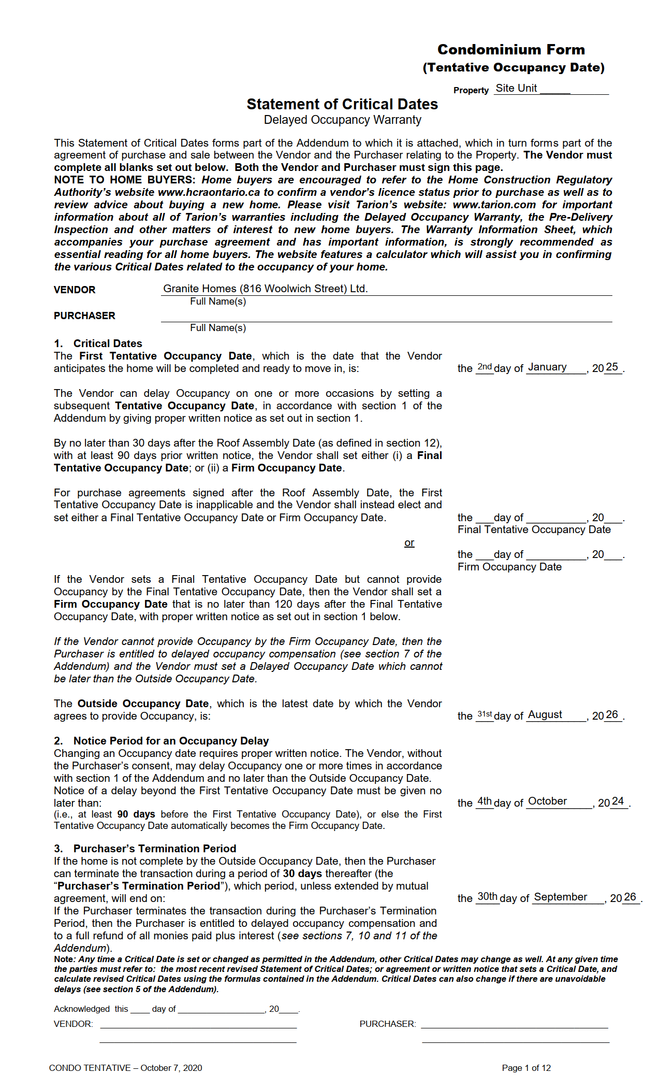

[LOTNUMBER]

[FIRSTNAME0000] [LASTNAME0000] [FIRSTNAME0001] [LASTNAME0001] [FIRSTNAME0002] [LASTNAME0002]

31
March
27

[FIRSTNAME0000] [LASTNAME0000] [FIRSTNAME0001] [LASTNAME0001] [FIRSTNAME0002] [LASTNAME0002]

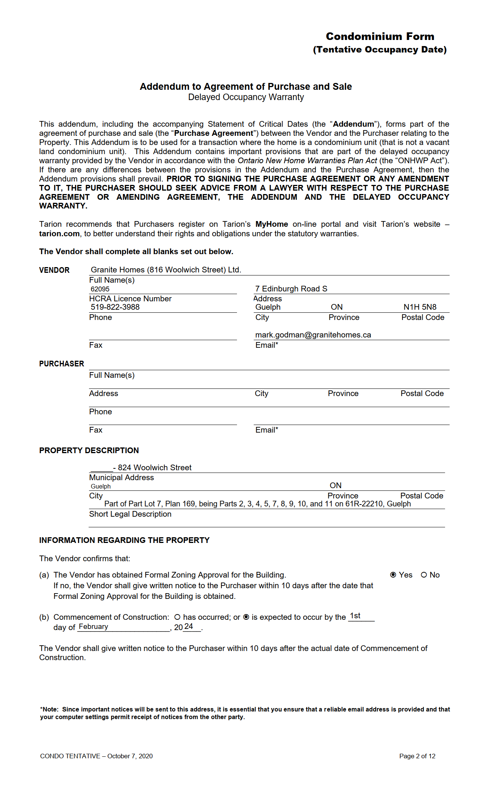

northside@granitehomes.ca

[FIRSTNAME0000] [LASTNAME0000] [FIRSTNAME0001] [LASTNAME0001] [FIRSTNAME0002] [LASTNAME0002]

[ZIP0000]
[STATE0000]
[CITY0000]
[STREETADDRESS10000]
[HOMEPHONE10000]

[EMAIL0000]
[FAXNUMBER0000]

[LOTNUMBER]
[LOTNUMBER]

N1H 6J2

December
December
December
December

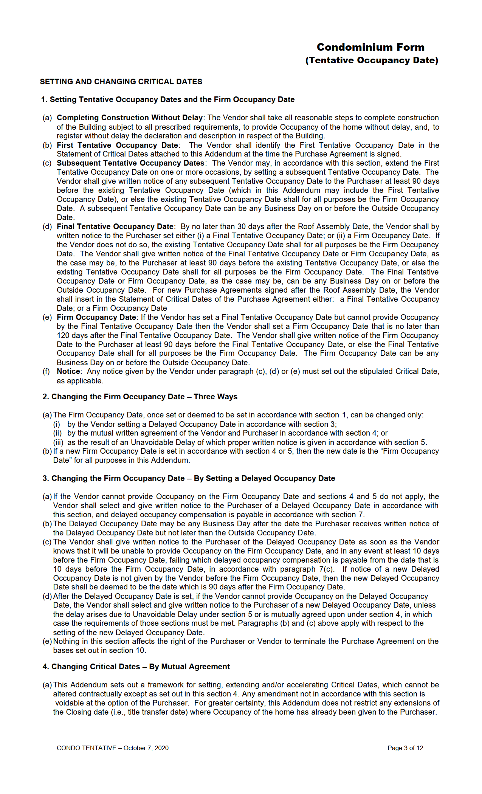

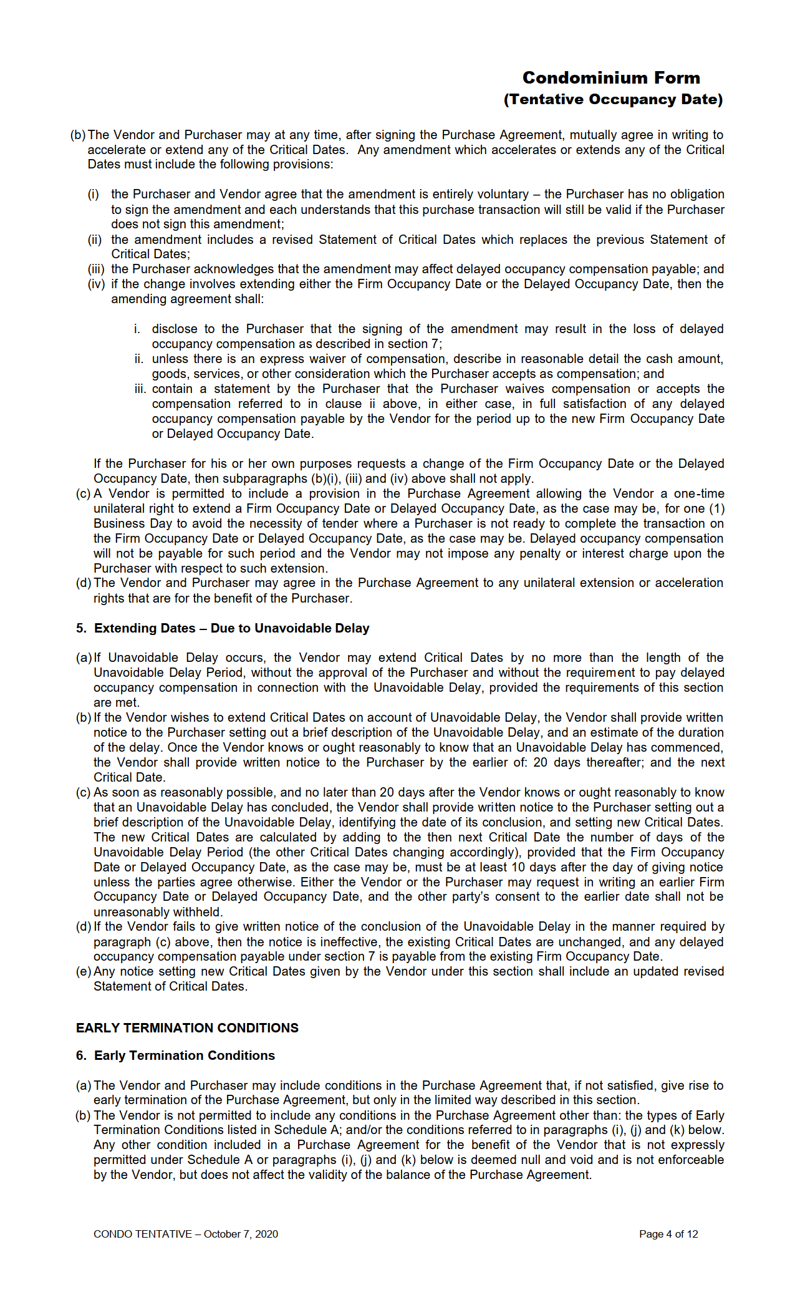

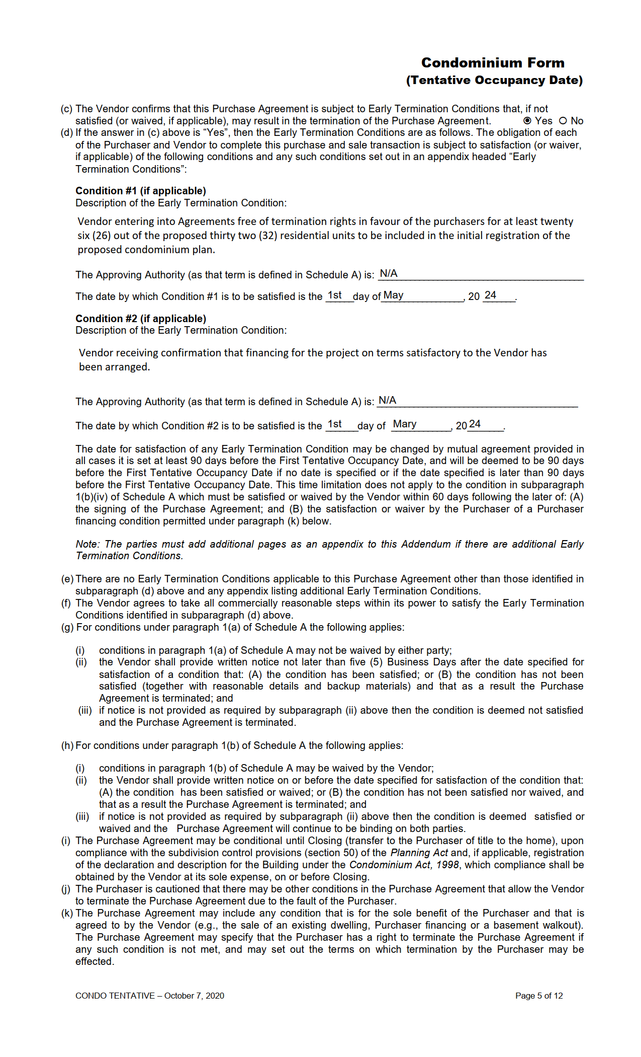

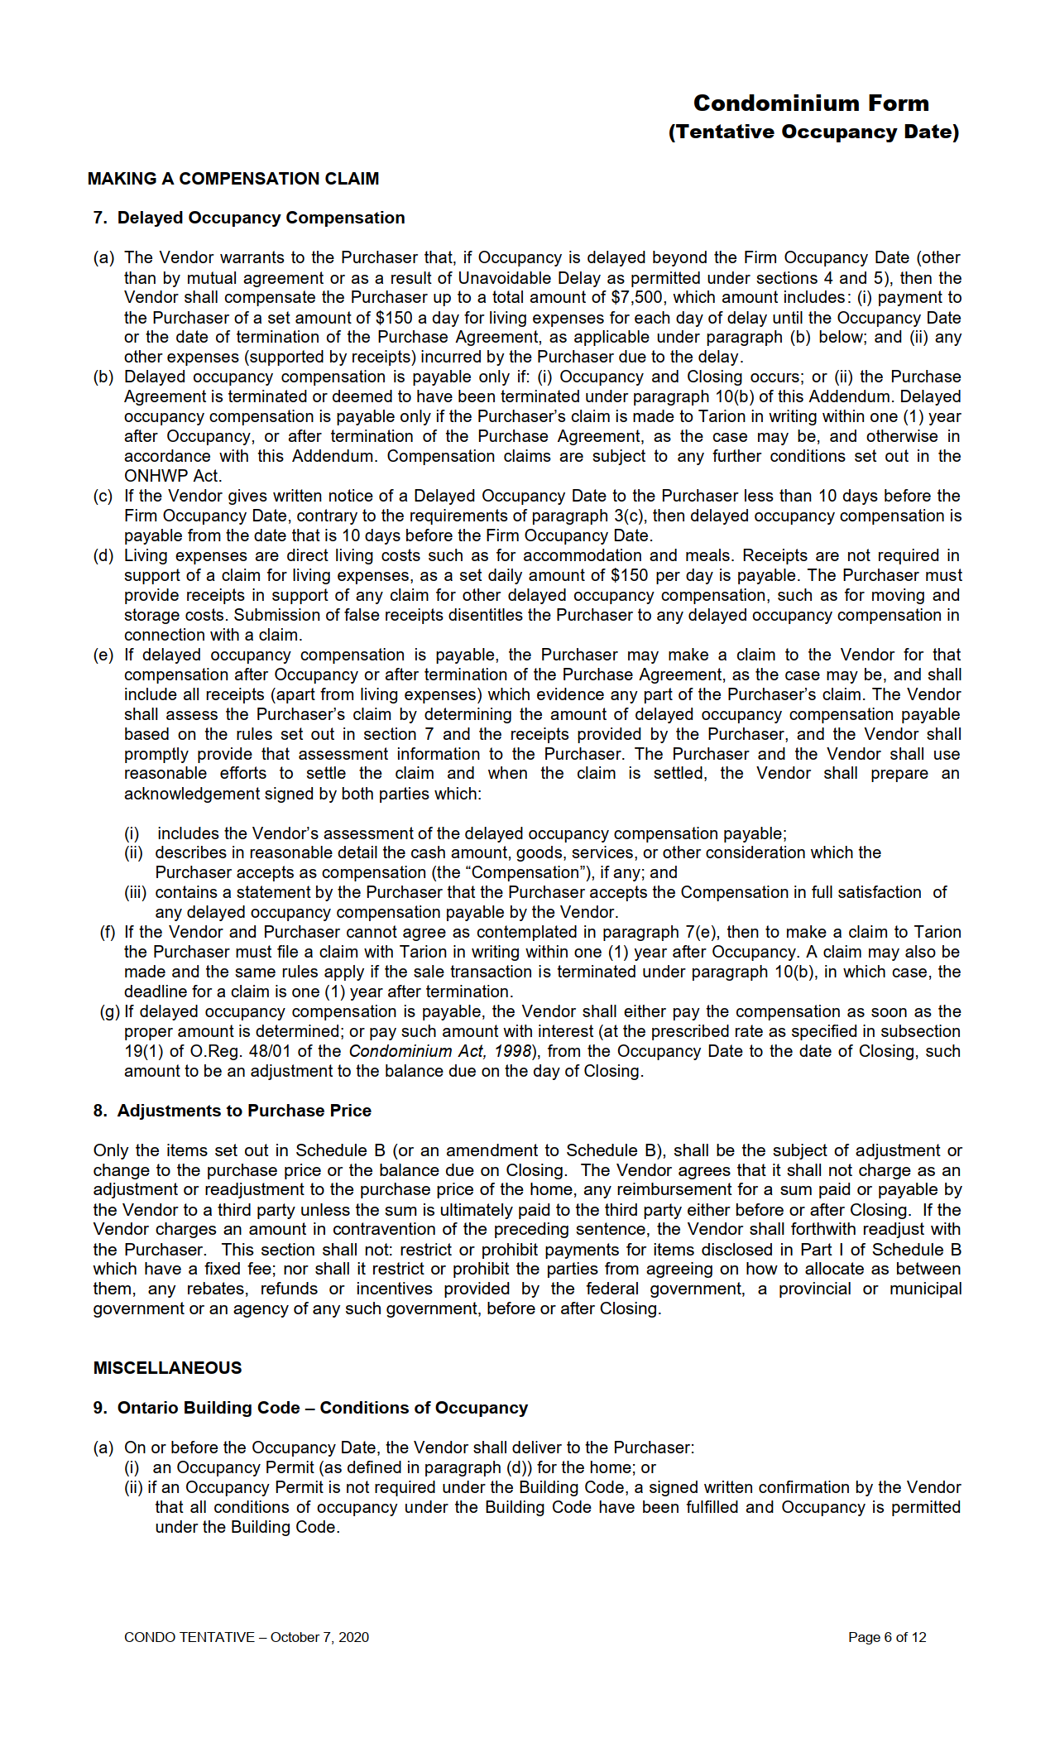

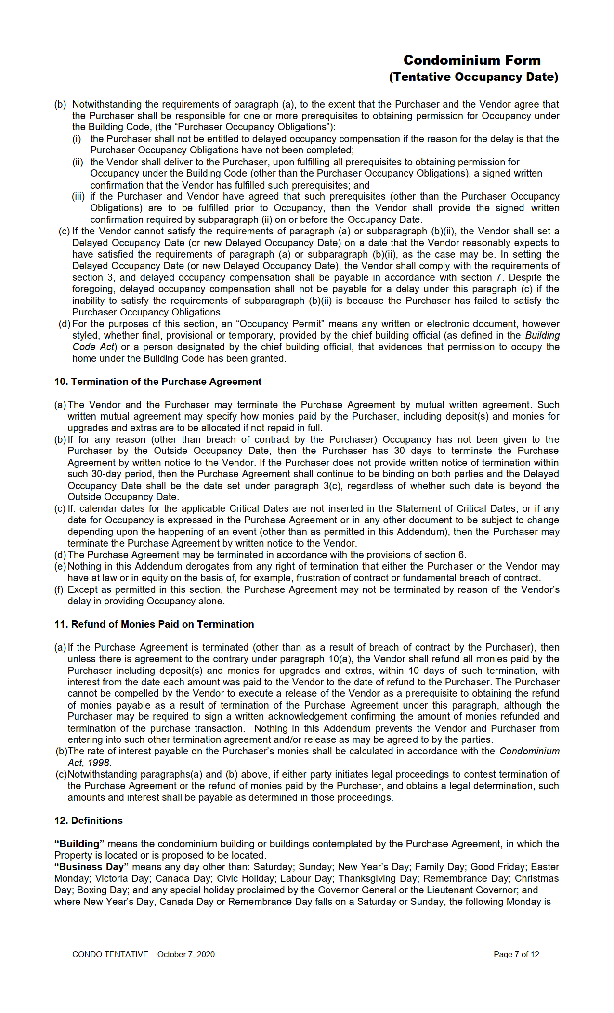

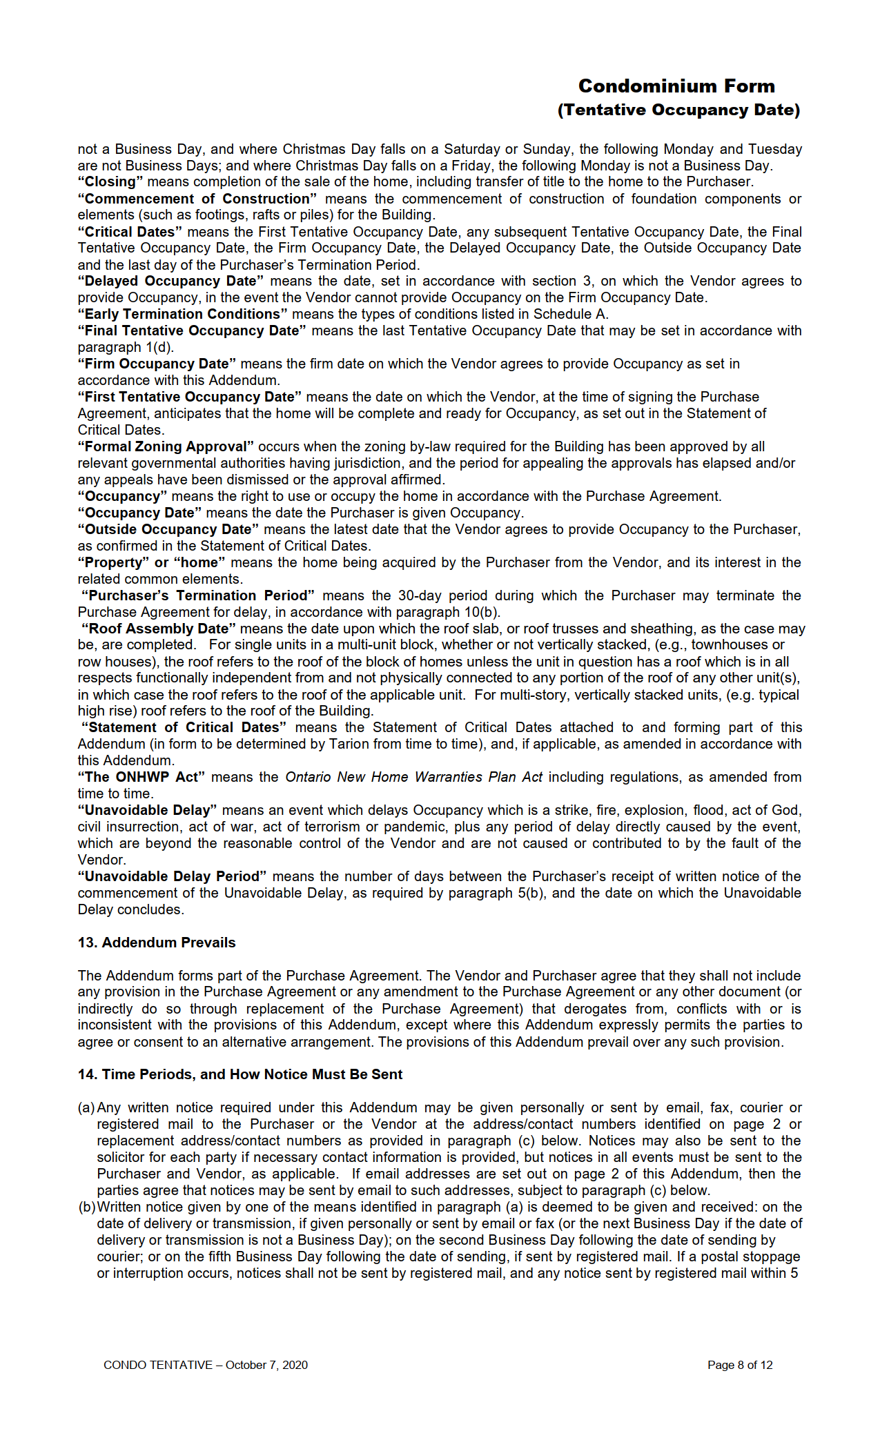

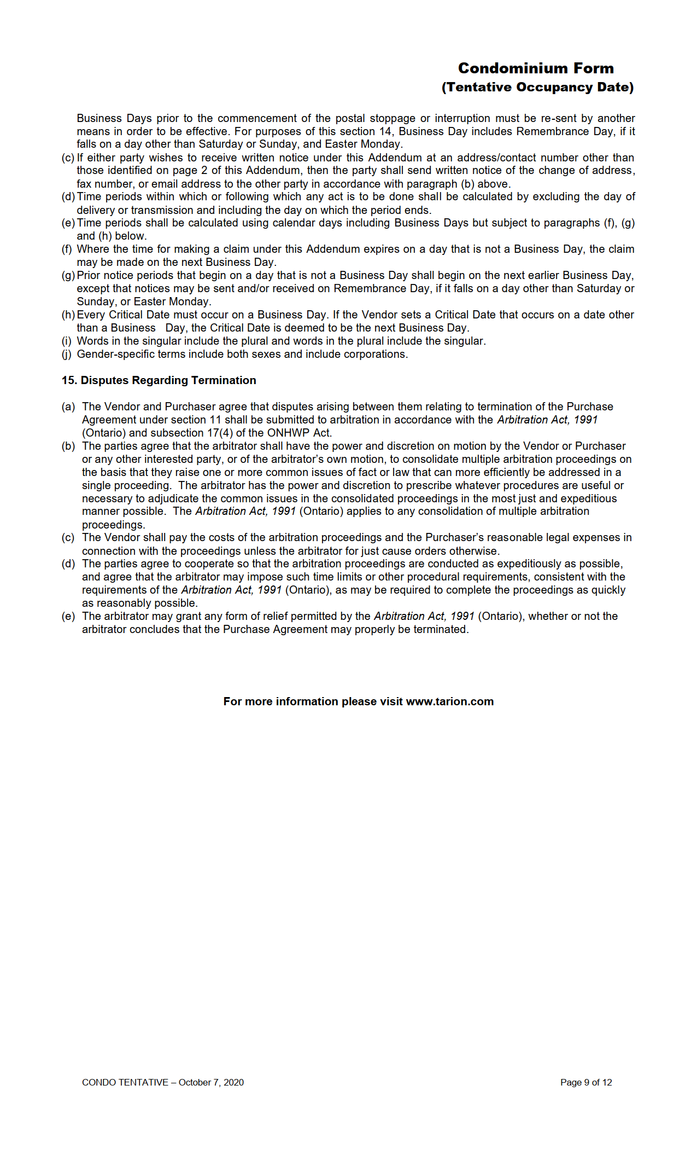

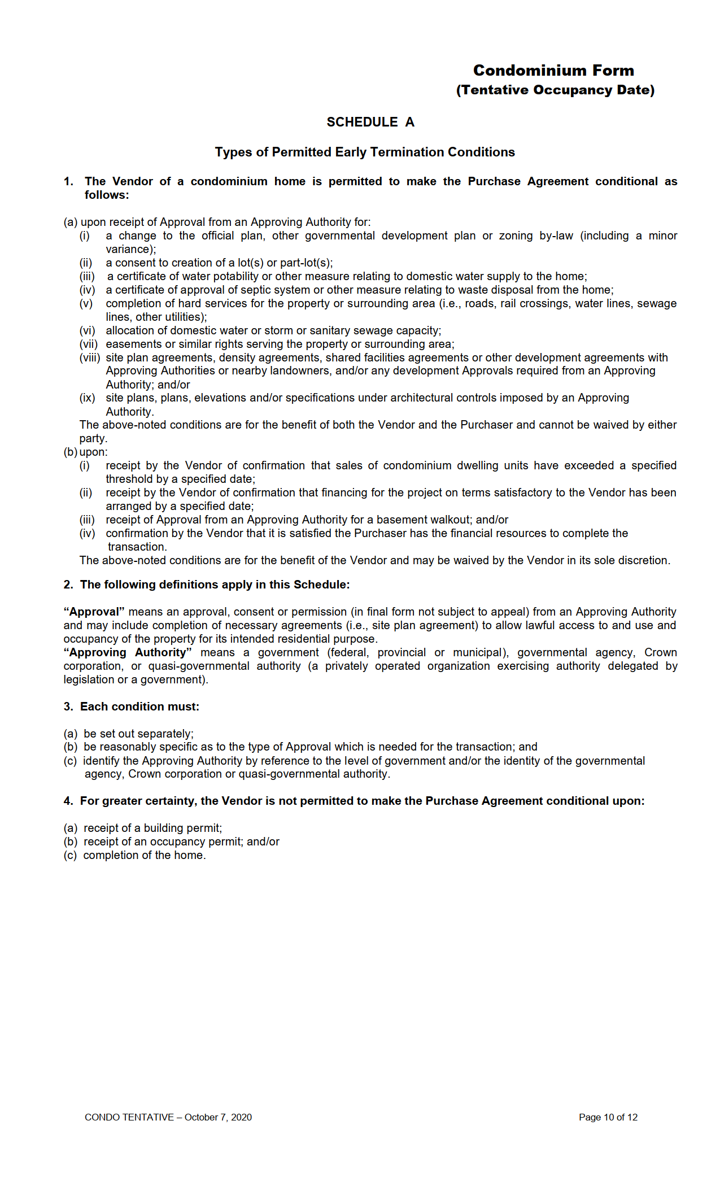

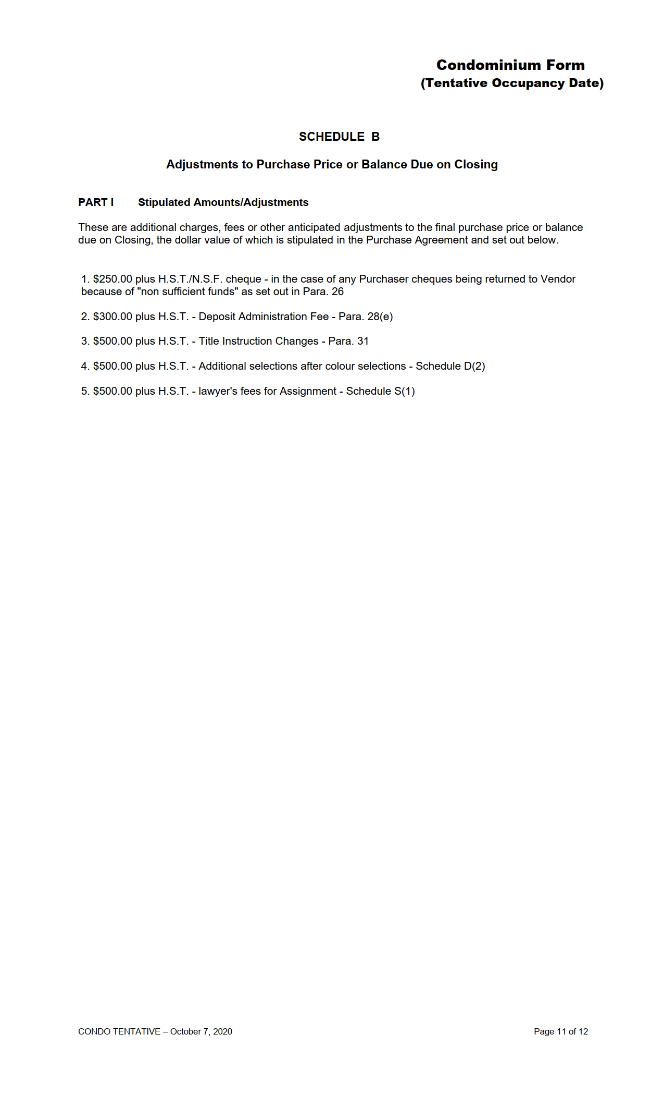

34

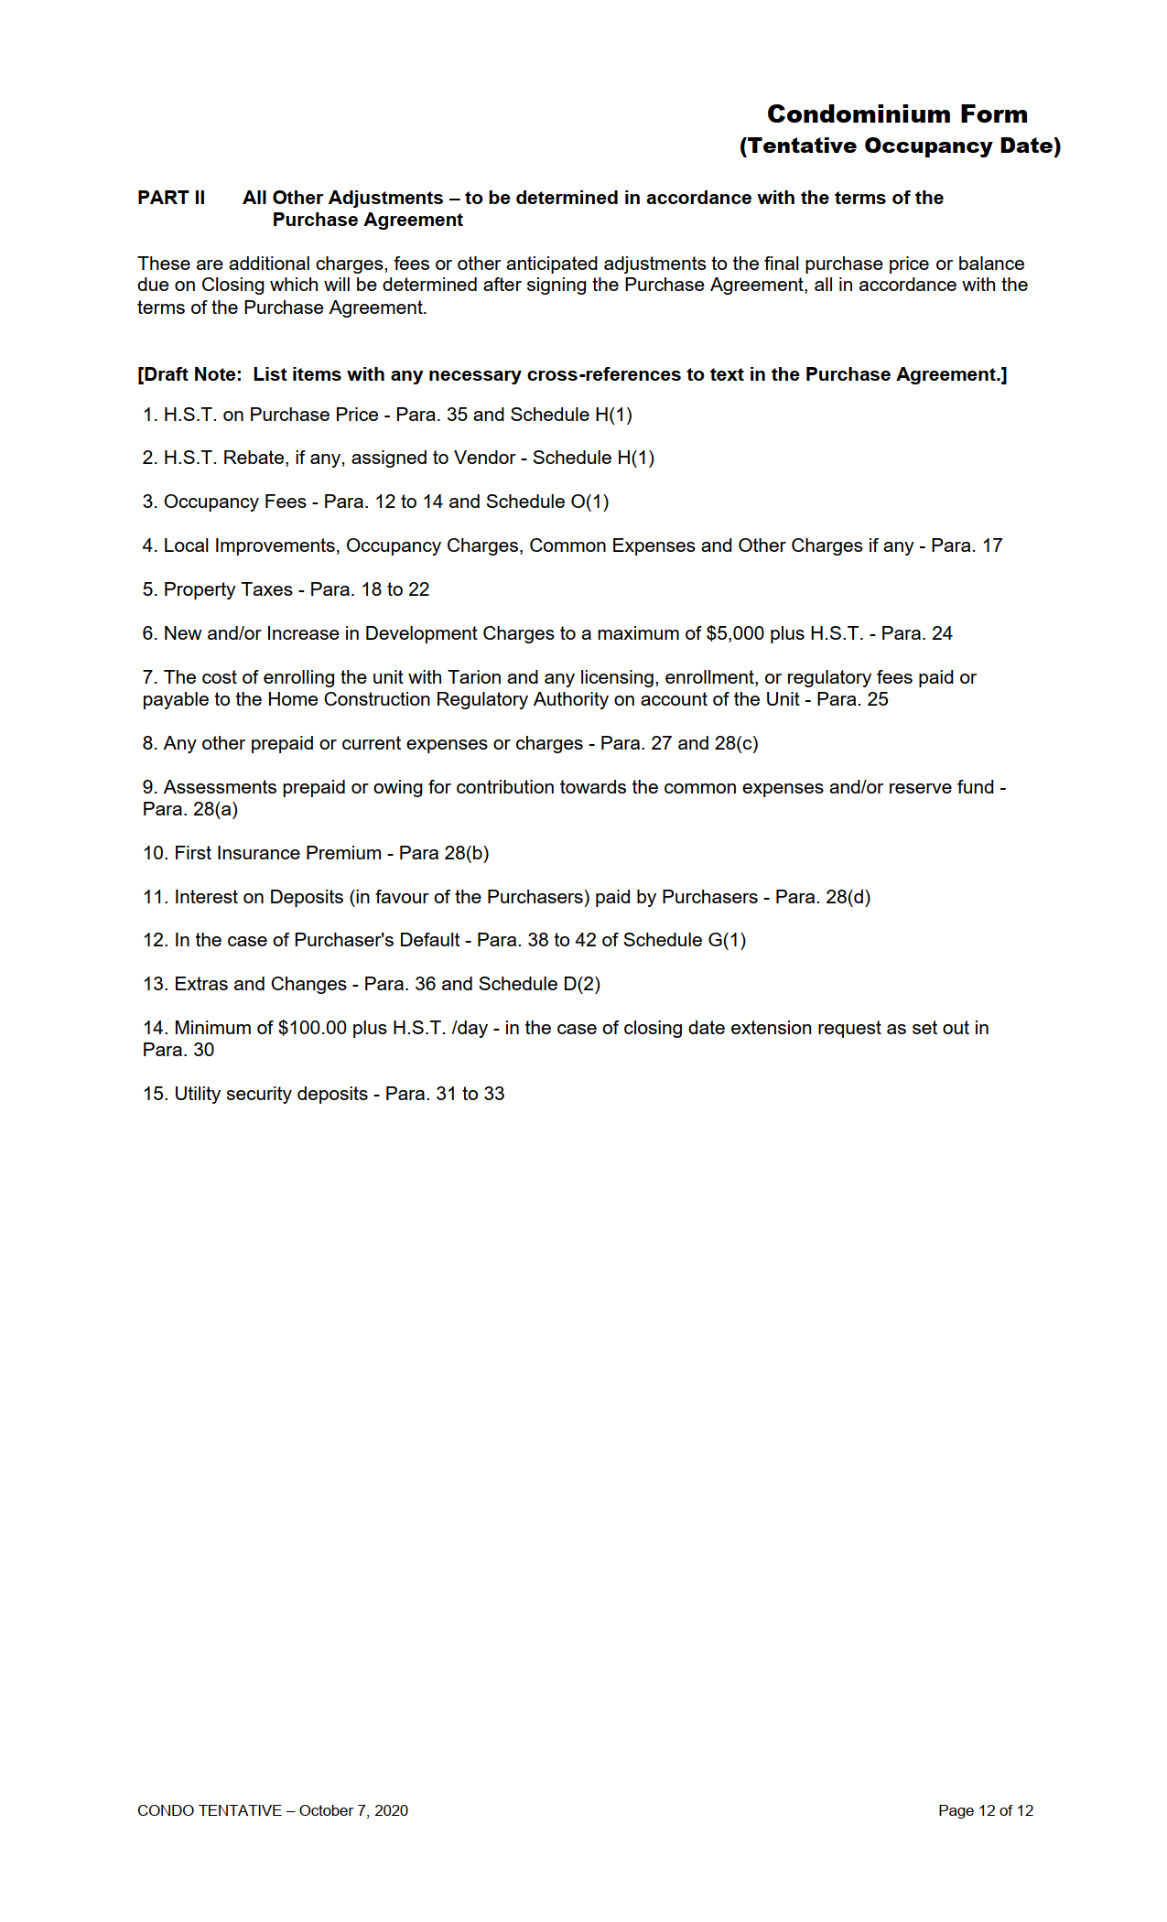

ROGERS CABLE ACKNOWLEDGEMENT
Rogers Cable Acknowledgement

To: Granite Homes (816 Woolwich Street) Ltd.
hereinafter called the Builder

Re: Purchaser Name(s)

Legally known as:
[FIRSTNAME0000] [LASTNAME0000] [FIRSTNAME0001] [LASTNAME0001] [FIRSTNAME0002] [LASTNAME0002]
[LOTNUMBER]
Unit Number:

Civic Address: [LOTNUMBER] 824 Woolwich Street, Guelph ON N1H 6J2

The Undersigned Purchaser(s) hereby acknowledges and agrees to allow the Builder to
provide to Rogers Cable Communications Inc. the name, address and contact details of the resident(s)
of the above property for marketing purposes.

[CITY0000]
DATED AT , this day of , 20___

Purchaser 1: [FIRSTNAME0000] [LASTNAME0000]

Purchaser 2: [FIRSTNAME0001] [LASTNAME0001]

Purchaser 3: [FIRSTNAME0002] [LASTNAME0002]

END OF DOCUMENT



The prescribed rate as stated in the regulations to the Act, is the rate of interest that the Bank of Canada has most recently reported as the chartered bank administered interest rate for a conventional one year mortgage as of the first of the month in which the Purchaser assumes interim occupancy of a proposed unit or is required to do so under the agreement of purchase and sale. As of April, 2025, this rate was 6.09%. The prescribed rate of interest is not known until the month of occupancy.

